**Please note: prices are subject to change.**

**Manufacturers: Alimed, Haworth, Humanscale, W. B. Mason, Steelcase, Varidesk**

**Chairs:**

**STEELCASE:**

**Leap:**

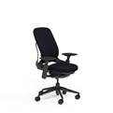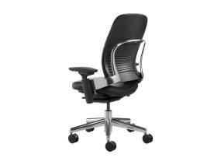

<https://www.steelcase.com/products/office-chairs/leap/>

**HAWORTH:**

**Improv high back chair with flipper arms that need to be specified when ordering:**

**Improv H.E.**

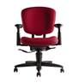

<http://www.haworth.com/products/seating/desk-chairs/improv-he>

**Improv XL**

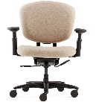

http://www.haworth.com/products/seating/desk-chairs/improv-xl

**Keyboards/Keyboard Trays:**

Microsoft® Natural Ergo Keyboard 4000, $52.29

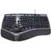

***Item:*** *MSFB2M00012*

* 14-degree gable
* Natural Arc
* Curved Keyboard

https://www.wbmason.com/ProductDetail.aspx?ItemID=MSFB2M00012&uom=EA&COID=&SearchID=223935295&ii=8

Microsoft® Wireless Desktop 5050 AES USB, $73.29

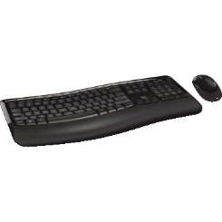

***Item:*** *MSFPP400001*

* Ergonomist-Approved Comfort Curve Design with built-in palm rest
* Wireless freedom and convenience
* Customizable shortcut keys
* BlueTrack Technology
* Computer/Operating System Requires a PC that meets the requirements for and has installed one of these operating systems: Windows 10, 8, 7 Mac OS X v10.4 -10.7

<https://www.wbmason.com/ProductDetail.aspx?ItemID=MSFPP400001&uom=EA&COID=&SearchID=223935295&ii=24>

Contour® RollerMouse® Pro3, $200.00

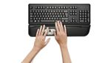

***Item#:*** *713746*

* Allows your arms to remain relaxed; point, click, and navigate with ease, using fingers of either hand. Removable, easy-to-clean palm supports. Plug and play. Wired. Black.
* 3-1/2"W x 20"L x 1-1/4"H • Compatible with Mac and Windows® • Compliant with PS/2 and USB interfaces • 2-year warranty

<https://www.alimed.com/contour-rollermouse-pro3.html>

6G SYSTEM WITH 900 BOARD AND SWIVEL MOUSE

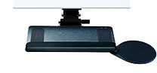

***Item#:*** *6G90011RG22*

* Sleek and intuitive, 7" height adjustable arm
* 900 Keyboard platform
* 8" Swivel mouse platform, right
* Gel palm support
* 22" Track
* Color: Black

https://www.humanscale.com/products/product-buy.cfm?group=KeyboardSystems

**MICE:**

HP HP Comfort Grip Wireless Mouse $21.45

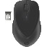

***Item:*** *HEWH2L63UT*

* Move around freely—up to 30' wireless range through a single USB dongle
* HP Link-5 technology connects five HP-compatible devices through one nano receiver
* LED indicator verifies connection to the laptop
* One-year limited warranty
* Extended battery life
* Includes one AA battery

<https://www.wbmason.com/ProductDetail.aspx?ItemID=HEWH2L63UT&uom=EA&COID=&SearchID=223008163&ii=4>

HP HP Slim Bluetooth Mouse $29.25

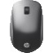

***Item:*** *HEWF3J92UT*

* Three programmable buttons and a central scrolling wheel support ambidextrous use
* Conserve PC ports with a Bluetooth mouse that pairs automatically—no USB required
* Compatible with multiple operating systems
* One-year limited warranty
* Extended battery life with convenient LED indicator that alerts you when batteries need to be changed
* Includes one AA battery

<https://www.wbmason.com/ProductDetail.aspx?ItemID=HEWF3J92UT&uom=EA&COID=&SearchID=223007551&ii=5>

Kensington® Expert Mouse Wireless Trackball, Four Buttons, Black, $112.08

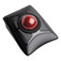

***Item:*** *KMW72359*

* Wireless connection via Bluetooth 4.0 LE or USB nano receiver.
* TrackballWorks software lets you customize all four buttons, adjust cursor speed.
* DiamondEye optical tracking technology for premium cursor control and accuracy.
* Award-winning Scroll Ring lets you scan up and down pages with ease.

<https://www.wbmason.com/ProductDetail.aspx?ItemID=KMW72359&uom=EA&COID=&SearchID=223005230&ii=9>

Logitech® Trackman Marble Mouse, Four-Button, Programmable, Dark Gray, $42.69

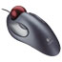

***Item:*** *LOG910000806*

* Ambidextrous trackball mouse keeps you comfortable and supported all day.
* Enjoy fast, accurate, fingertip cursor control.
* Smooth-tracking Marble optical technology.
* Long, broad palm area and gentle curve design.

Green Item

<https://www.wbmason.com/ProductDetail.aspx?ItemID=LOG910000806&uom=EA&COID=&SearchID=223009562&ii=145>

Kensington® Optical Orbit Trackball Mouse, Two-Button, Black/Silver, $38.79

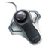

***Item:*** *KMW64327*

* Control your cursor with a simple touch of the finger.
* Uses less arm movement and desk space than a conventional mouse.
* Features Diamond Eye optical technology for precise tracking.
* Resistant to dust, reducing the need for regular trackball cleaning.

<https://www.wbmason.com/ProductDetail.aspx?ItemID=KMW64327&uom=EA&COID=&SearchID=223009562&ii=164>

Logitech® M570 Wireless Trackball, Four Buttons, Scroll, Black/Blue, $53.39

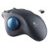

***Item:*** *LOG910001799*

* Sculpted, stays-put design supports your hand comfortably.
* Connects using the tiny, leave-in Logitech Unifying receiver.
* Reliability of long-range, advanced 2.4 GHz wireless connectivity.
* Extended 18 month battery life.

<https://www.wbmason.com/ProductDetail.aspx?ItemID=LOG910001799&uom=EA&COID>=

Kensington® Orbit Trackball with Scroll Ring, Two Buttons, Black, $47.39

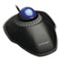

***Item:*** *KMW72337*

* Fast, easy scrolling.
* Hand-friendly design.
* Precise tracking.
* Includes detachable wrist rest.

<https://www.wbmason.com/ProductDetail.aspx?ItemID=KMW72337&uom=EA&COID=&SearchID=223009562&ii=173>

Kensington® Orbit Wireless Trackball, Black/Red, $51.29

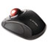

***Item:*** *KMW72352*

* Wireless mouse with 2.4 GHz nano receiver.
* Precise cursor control.
* Touch scrolling for effortless control.

<https://www.wbmason.com/ProductDetail.aspx?ItemID=KMW72352&uom=EA&COID=&SearchID=223009562&ii=194>

Kensington® Wireless Mouse for Life, Left/Right, Black, $24.98

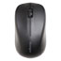

***Item:*** *KMW72392*

* Silent clicking for quiet environments.
* 2.4GHz wireless freedom with storable nano receiver.
* Ambidextrous, contoured shape for either right-handed or left-handed users.
* High-definition optical sensor (1000 DPI) for responsive control.

<https://www.wbmason.com/ProductDetail.aspx?ItemID=KMW72392&uom=EA&COID=&SearchID=223009562&ii=228>

Evoluent® VerticalMouse™ 4, $112.75

***Item:*** *711941*

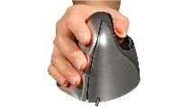

* VerticalMouse patented new shape supports your hand in a relaxed hand-shake position
* Five programmable mouse buttons
* VerticalMouse Relaxes Your Wrist
* **Evoluent® VerticalMouse™ 4** New adjustable laser sensor controls pointer speed and can be adjusted without changing grip. Top-mounted LEDs show selected pointer speed. Six programmable buttons, vertical scroll, auto click and click lock.
* Evoluent VerticalMouse 4 wired and wireless versions compatible with Windows® XP, 7, 8, and 10, and Mac OS 10.5 or later • Bluetooth version compatible with Mac OS 10.5 or later only • USB only
* Sizing: Measure from the base of the palm to the tip of the middle finger. For hands 7” or larger, choose Regular; for hands smaller than 7”, choose Small.
* WARNING: This product can expose you to chemicals including DI(2-ETHYLHEXYL) PHTHALATE (DEHP), which is known to the State of California to cause cancer and birth defects or other reproductive harm. For more information go to [www.P65Warnings.ca.gov](https://www.p65warnings.ca.gov/).

<https://www.alimed.com/verticalmouse.html>

Contour® Optical Mouse, $79.75

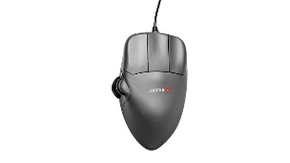

***Item:*** *710939*

* Pick the size that exactly fits your hand, right or left!
* Molded to fit your hand comfortably
* Helps prevent repetitive stress injuries
* Durable, rubberized surface is easy to grip
* For sizing instructions, click on the "descriptions" tab
* The Mouse That Fits YOUR Hand!
* The Contour Optical Mouse has a molded-to-fit-the-hand shape and a durable, rubberized surfaces for easier gripping. Multiple sizes and right and left orientations let you choose the mouse that's perfect for you. Ergonomic design helps prevent repetitive stress injuries.
* Contour's design allows you to rest your hand on top of the mouse, promoting straight alignment of your hand and wrist while elevating your wrist from the desk. Elongated buttons allow you to use the second knuckle of your finger to click. When you click this way (instead of with fingertips) you use a stronger tendon with small, subtle motions and automatically avoid flexing your fingers.
* Your thumb rests naturally on the side of the mouse where you have both the scroll wheel and a rocker switch.
* If you need to focus on detailed precision work, which is often combined with high cursor speed, you can switch to a precision grip where the mouse is held with all all five fingertips.
* True three-button design. The Contour Mouse offers a full-size third mouse button, making middle clicking as smooth as a regular click. This gives you the option of having a frequent command just an easy click away.
* Mouse is corded. Gunmetal Gray. Available in Left or Right. Formerly known as the "Perfit" mouse.
* USB device • Compatible with PC, Mac, UNIX • SUN port compatibility version available by special order. Sizing: Measure from base of palm to the tip of the middle finger.
* Small fits hands 6" to 6-3/4"
* Medium fits hands 6-3/4" to 7-1/2"
* Large fits hands 7-1/2" to 8-1/4"
* X-Large fits hands over 8-1/4"
* WARNING: This product can expose you to chemicals including DI(2-ETHYLHEXYL) PHTHALATE (DEHP), which is known to the State of California to cause cancer and birth defects or other reproductive harm. For more information go to [www.P65Warnings.ca.gov](https://www.p65warnings.ca.gov/).

https://www.alimed.com/contour-mouse-optical.html

Switch Mouse, $178.00

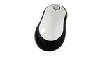

***Item:*** *72654*

* Boosts comfort and reduces risk of injury
* Adjustable length
* Programmable buttons
* V-shape creates natural angle
* The Switch Mouse accommodates both left or right hand users. V-shaped base positions wrist and arm at a natural angle. Adjustable length ensures proper fit for most users. Built-in palm support to prevent contact stress on the wrist. Four-way scrolling dish to minimize repetitive motion. Programmable buttons for common functions.   
  Optical scanning • USB • Compatible with Windows® 2000, XP, Vista, 7 • Mac OS (plug-n-play only)*
* *Switch Mouse drivers are currently available for Windows® only. Switch Mouse works with Mac OS as a plug-and-play input device with standard mouse functionality, including left/right buttons and up/down scrolling; excludes side-to-side scrolling or programmable button functions. All other ergonomic features of the Switch Mouse can be utilized by both Mac and PC users.
* WARNING: This product can expose you to chemicals including DI(2-ETHYLHEXYL) PHTHALATE (DEHP), which is known to the State of California to cause cancer and birth defects or other reproductive harm. For more information go to [www.P65Warnings.ca.gov](https://www.p65warnings.ca.gov/).

<https://www.alimed.com/switch-mouse.html>

Penguin Vertical Mouse, $90.00

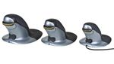

***Item:*** *712898*

* Encourages use of larger muscle groups for maneuvering
* Innovative design helps users avoid RSI and CTS
* Available in wired and wireless versions

https://www.alimed.com/_resources/common/userfiles/image/Antimicrobialicon5050.jpg

Penguin Ambidextrous Vertical Mouse encourages a safe and ergonomic alignment of your hand, wrist, and forearm. The innovative design helps avoid Repetitive Stress Injury (RSI) and Carpal Tunnel Syndrome (CTS). An antimicrobial coating keeps the operator safe from germs. Easy-glide base allows users to rest either hand comfortably on both sides. Available in Wired or Wireless versions and 3 sizes for a perfect fit. Black/Silver.

Adjustable 400, 600, 800, or 1200-DPI pointer speeds • Laser tracking and precision scroll wheel • Plug-and-play USB 2.0 • Compatible with Windows® XP, 2000, Vista, 7, 8, 10; Mac OS X, and Linux • Charging cable included for Wireless version

Sizing: Measure from the bottom of the hand to the tip of the middle finger.

Small: 0"-6"

Medium: 6"-7"

Large: 7"

WARNING: This product can expose you to chemicals including DI(2-ETHYLHEXYL) PHTHALATE (DEHP), which is known to the State of California to cause cancer and birth defects or other reproductive harm. For more information go to [www.P65Warnings.ca.gov](https://www.p65warnings.ca.gov/).

<https://www.alimed.com/penguin-mouse-24264.html>

Rockstick 2 Mouse, $109.75

***Item:*** *713348 small and 713349 large*

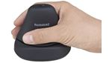

* Updated Rockstick Mouse allows you to click with your larger hand muscles instead of your fingers
* Ambidextrous mouse
* Upright comfortable Rockstick grip
* Hand is positioned at 60º for maximum comfort



**Rockstick2 Mouse** with ambidextrous design reduces work load for both hands by allowing users to operate by either the right or left hand. Rockstick Mouse enables users to work in balance throughout the day by distributing the repetitive actions of mousing to both hands. Rockstick's unique design allows users to click by utilizing the strength of the entire hand instead of just the fingers reducing pain and strain. The repetitive strain on the fingers eventually leads to inflammation and swelling of the finger flexor tendons. With Rockstick Mouse users rest their fingers on the handle without preparation to click, all fingers remain relaxed and supported at all times helping to eliminate finger hovering and lifting.

Rockstick Mouse reduces wrist and forearm pronation by positioning the hand at a 60º angle off the horizontal, which is a more natural position when mousing. The Rockstick Mouse's Ergo-Grip design offers the utmost precision in fingertip control. Also the laser pointer control is as accurate as any other high-quality performance mouse with on-mouse adjustable DPI controls.

**Rockstick2 Mouse has been awarded the 2014 Red Dot Design Award for Communication Design and Design Concept.**

Rockstick2 Mouse is 2.4 GHZ wireless with a range of 32.8' (1-m). Laser resolution: 800, 1200, 1600, 2000 DPI. Rockstick2 Mouse is compatible with Windows 7, Windows Vista, Windows 2000, Windows XP, Mac OS9, Mac OS10X (10.2.8 or later), Linux

**Rockstick2 Mouse Small/Medium Dimensions:** Width: 3.5" (8.8cm). Depth (front to back): 3.6" (9.1cm). Height: 3.15" (8cm)

**Rockstick2 Mouse Large Dimensions:** 3.7" (9.4cm). Depth (front to back): 3.86" (9.8cm). Height: 3.54" (9.0cm) •

WARNING: This product can expose you to chemicals including DI(2-ETHYLHEXYL) PHTHALATE (DEHP), which is known to the State of California to cause cancer and birth defects or other reproductive harm. For more information go to [www.P65Warnings.ca.gov](https://www.p65warnings.ca.gov/).

<https://www.alimed.com/rockstick2-mouse.html>

**MOUSE BRIDGE:**

MouseOver, $40.75

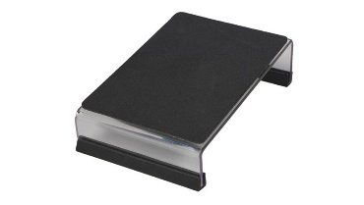

***Item#:*** *78621*

* MouseOver brings the mousing surface closer to your work area to prevent repetitive reaching and strains. This strong, clear acrylic device has a cleanable neoprene pad and fits over the number pad area of traditional and natural style keyboards. Excellent for left and right-handed users, it works with optical or standard mice. Position it on either side, the nonslip pad ensures it won't move during use.
* 6"W x 2-1/4"H x 8-1/2"L in back, 1-5/8"H in front
* WARNING: This product can expose you to chemicals including DI(2-ETHYLHEXYL) PHTHALATE (DEHP), which is known to the State of California to cause cancer and birth defects or other reproductive harm. For more information go to [www.P65Warnings.ca.gov](https://www.p65warnings.ca.gov/).

<https://www.alimed.com/versatech-mouseover-3.html>

**WRIST RESTS and MOUSE RESTS:**

Fellowes® Gel Wrist Support, Graphite, $22.79

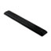

***Item:*** *FEL91737*

* Gel-filled wrist support.
* Durable Lycra covering.
* Covering resists stains.
* Nonskid base.

<https://www.wbmason.com/ProductDetail.aspx?ItemID=FEL91737&uom=EA&COID>=

3M™ Gel Antimicrobial Large Mouse Wrist Rest, Black, $28.39

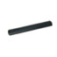

***Item:*** *MMMWR310LE*

* Features antimicrobial product protection.
* Firm enough to provide the support you need, but soft enough for optimal comfort.
* Guaranteed not to leak and are puncture-resistant under normal use.
* Durable nonskid backing.

Green ItemRecycled Item

<https://www.wbmason.com/ProductDetail.aspx?ItemID=MMMWR310LE&uom=EA&COID=&SearchID=223009562&ii=113>

3M™ Gel Thin Wrist Rest, Extended Length, Black Leatherette, $36.79

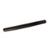

***Item:*** *MMMWR340LE*

* Features antimicrobial product protection.
* Firm enough to provide the support you need, but soft enough for optimal comfort.
* Guaranteed not to leak and are puncture-resistant under normal use.
* Durable nonskid backing.

Green ItemRecycled Item

<https://www.wbmason.com/ProductDetail.aspx?ItemID=MMMWR340LE&uom=EA&COID>=

3M™ Precise Leatherette Mouse Pad w/Wrist Rest, Nonskid Base, 8-3/4 x 9-1/4, Black, $28.39

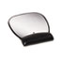

***Item:*** *MMMMW310LE*

* Features antimicrobial product protection.
* Firm enough to provide the support you need, but soft enough for optimal comfort.
* Guaranteed not to leak and are puncture-resistant under normal use.
* Durable nonskid backing.

Green ItemRecycled Item

<https://www.wbmason.com/ProductDetail.aspx?ItemID=MMMMW310LE&uom=EA&COID=&SearchID=223009562&ii=107>

3M™ Gel Mouse/Trackball Wrist Rest, Black Leatherette, $14.59

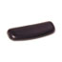

***Item:*** *MMMWR305LE*

* Features antimicrobial product protection.
* Firm enough to provide the support you need, but soft enough for optimal comfort.
* Guaranteed not to leak and are puncture-resistant under normal use.
* Durable nonskid backing.

Green ItemRecycled Item

<https://www.wbmason.com/ProductDetail.aspx?ItemID=MMMWR305LE&uom=EA&COID=&SearchID=223009562&ii=123>

**Purchasing @ Bentley-Better pricing agreement than via W. B. Mason; Contact Purchasing Department**

**Keyboard Trays**

Humanscale 6G Keyboard System with Clip Mouse, $318.29 at W. B. Mason

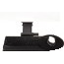

***Item#:*** *HUM6G90090HG22*

* Superior design
* Unmatched strength and stability while providing maximum knee clearance and the simplest user experience possible
* Clip mouse provides depth, swivel, tilt, height and left/right adjustability to accommodate all users

<https://www.wbmason.com/ProductDetail.aspx?ItemID=HUM6G90090HG22&uom=EA&COID=&SearchID=223009562&ii=241>

**SHOULDER RESTS/HEADSETS w/AMPLIFIER:**

Innovera® Telephone Shoulder Rest, Gel Padded, Black, $10.49

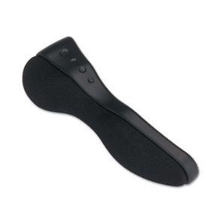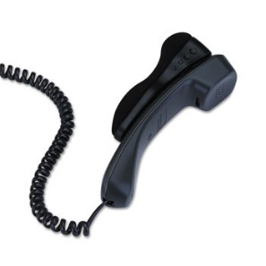

***Item:*** *IVR10101*

* Reduces neck and shoulder strain.
* Fits either shoulder.
* Attaches easily.
* For regular and Trimline phones.

Green Item Recycled Item

<https://www.wbmason.com/ProductDetail.aspx?ItemID=IVR10101&uom=EA&COID=&SearchID=98845524&ii=1>

Plantronics® SupraPlus Over-Head Cord Telephone Wideband Professional Headset, $113.99

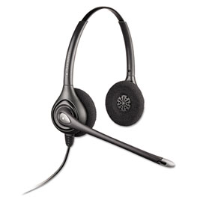

***Item:*** *PLNHW261N*

* Item #PLNM22 (adapter) must be ordered to complete the headset.
* Premium audio quality.
* Rich, natural communication.
* Comfortable design.

<https://www.wbmason.com/ProductDetail.aspx?ItemID=PLNHW261N&uom=EA&COID=&SearchID=98846293&ii=7>

Plantronics® SupraPlus Over-Head Wideband Professional Headset for Amplifiers/USB Adapters, $104.99

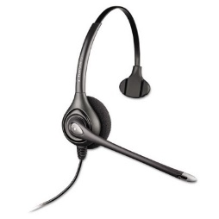

***Item:*** *PLNHW251N*

* Premium audio quality.
* Rich, natural communication.
* Comfortable design.

<https://www.wbmason.com/ProductDetail.aspx?ItemID=PLNHW251N&uom=EA&COID=&SearchID=98846740&ii=8>

Plantronics® Vista M22 Audio Processor, $119.99

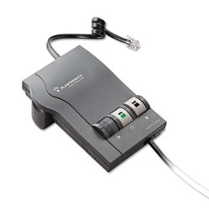

***Item:*** *PLNM22*

* Adds value to VoIP and PBX phone systems.
* Clearline audio technology.
* Quick Disconnect feature.
* Easy to use.

<https://www.wbmason.com/ProductDetail.aspx?ItemID=PLNM22&uom=EA&COID=&SearchID=98847502&ii=5>

Plantronics® S11 System Over-the-Head Telephone Headset w/Noise Canceling Microphone, $89.95

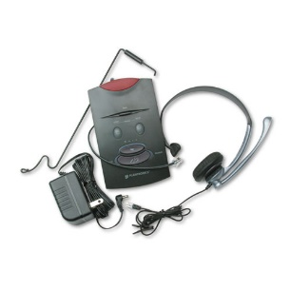

***Item:*** *PLNS11*

* Connects to single- or multi-line phones.
* Hands free convenience and comfort.
* Noise-canceling microphone.
* Compatible with most phones; volume/mute control.

<https://www.wbmason.com/ProductDetail.aspx?ItemID=PLNS11&uom=EA&COID=&SearchID=98848153&ii=14>

**MONITOR RISERS:**

### Fellowes® Standard Monitor Riser, 13 1/8 x 13 1/2 x 2, Platinum/Graphite, $30.89

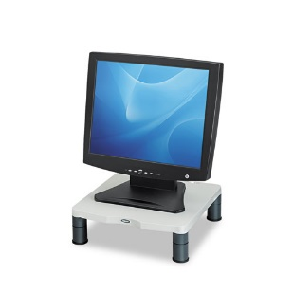

***Item:*** *FEL91712*

* Innovative stacking columns raise your monitor to your most comfortable level.
* Sturdy construction ensures strength and durability.
* Designed to support most 21" monitors up to 60 lbs.
* Convenient cord management.

<https://wbmason.com/ProductDetail.aspx?ItemID=FEL91712&uom=EA&COID=&SearchID=117692519&ii=1>

### Fellowes® Standard Monitor Riser, 19 7/8 x 14 1/16 x 6 1/2, Black/Silver, $52.39

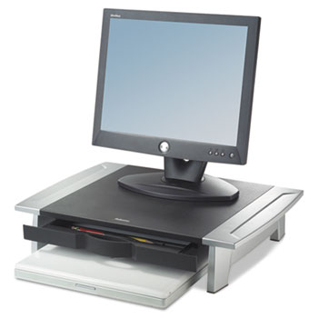

***Item:*** *FEL8031101*

* Adjustable riser lets you customize viewing level (range between 4" and 6 1/2") to prevent neck strain.
* Convenient storage tray holds paper, pens and clips.
* Stows laptop underneath for space-saving storage.
* Nonskid rubber feet protect work surface from scratches and scuffs.

<https://www.wbmason.com/ProductDetail.aspx?ItemID=FEL8031101&uom=EA&COID>=

### 3M™ Adjustable Height Monitor Stand, 12 x 15 x 1-5 7/8, Black/Silver, $45.29

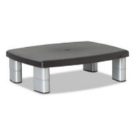

***Item:*** *MMMMS80B*

* Adjusts to ensure correct ergonomic positioning.
* Large platform supports monitor, laptop or printer up to 21" or 80 lbs.
* Storage helps maximize workspace.

Green Item

<https://www.wbmason.com/ProductDetail.aspx?ItemID=MMMMS80B&uom=EA&COID=&SearchID=223985275&ii=26>

**LAPTOP RISERS:**

### Fellowes® Office Suites Laptop Riser, 15 1/8" x 11 3/8" x 4 1/2"-6 1/2", Black/Silver, $28.69

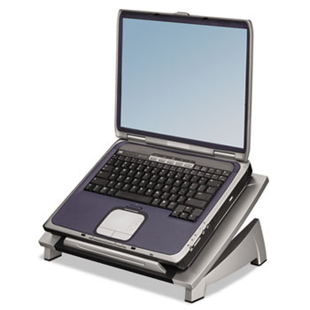

***Item:*** *FEL8032001*

* Adjustable tilt provides the optimal keyboard level and viewing angle
* Front bar holds laptop in place and keeps it from sliding forward
* Supports a 17" laptop or up to 10 lbs.
* Tough, impact-resistant plastic construction

<https://www.wbmason.com/ProductDetail.aspx?ItemID=FEL8032001&uom=EA&COID=&SearchID=223981538&ii=5>

### Fellowes® Office Suites Laptop Riser Plus, 15 1/8 x 11 3/8 x 6 1/2, Black/Silver, $43.99

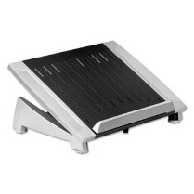

***Item:*** *FEL8036701*

* Raise your monitor or laptop to eye-level.
* Stabilizing front edge holds laptop in place.
* In-line copyholder places work at a comfortable viewing position.
* Cooling vents help dissipate laptop heat.

Green Item

<https://www.wbmason.com/ProductDetail.aspx?ItemID=FEL8036701&uom=EA&COID=&SearchID=223983381&ii=4>

**DOCUMENT HOLDERS:**

### 3M™ Fold-Flat Freestanding Desktop Copyholder, Plastic, 150 Sheet Capacity, Black, $20.99

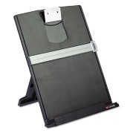

***Item:*** *MMMDH340MB*

* Sturdy, stable design with nonskid bottom.
* Grooved ledge and clip.
* Folds flat for storage.

<https://www.wbmason.com/ProductDetail.aspx?ItemID=MMMDH340MB&uom=EA&COID>=

### 3M™ In-Line Adjustable Desktop Copyholder, Plastic, 150 Sheet Capacity, Black/Clear, $81.99

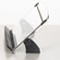

***Item:*** *MMMDH630*

* Adjustable elastic guideline secures thick documents.
* Won't block lower edge of monitor.
* Nonslip, grooved ledge.

<https://www.wbmason.com/ProductDetail.aspx?ItemID=MMMDH630&uom=EA&COID=&SearchID=223992582&ii=6>

### Fellowes® Professional Series Document Holder, Plastic, 250 Sheet Capacity, Black

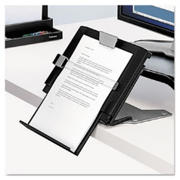

***Item:*** *FEL8039401*

* Places documents between monitor and keyboard for optimal ergonomic viewing range.
* Promotes neutral posture.
* Offers six separate angle adjustments from 75 to 25 incline.
* Top and bottom adjust to accommodate oversized documents.

<https://www.wbmason.com/ProductDetail.aspx?ItemID=FEL8039401&uom=EA&COID>=

### 3M™ Swing Arm Copyholder, Adhesive Monitor Mount, Plastic, 30 Sheet Capacity, Black, $11.59

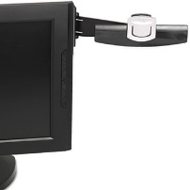

***Item:*** *MMMDH240MB*

* Attaches to either side of most flat panel monitors.
* Swings out of the way when not in use.
* Includes Command Adhesive to hold securely yet remove cleanly.

<https://www.wbmason.com/ProductDetail.aspx?ItemID=MMMDH240MB&uom=EA&COID>=

**FOOTRESTS:**

### Kensington® SoleMate Comfort Footrest with SmartFit System, 3-1/2h to 5h, Black/Gray, $82.39

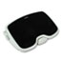

***Item:*** *KMW56144*

* Supports legs to reduce muscle strain and fatigue.
* Nonskid feet for stability.
* Full-featured foot rest with greater leg, back and foot comfort.
* Luxurious memory foam soothes tired feet and eliminates stress on pressure points.

https://www.wbmason.com/ProductDetail.aspx?ItemID=KMW56144&uom=EA&COID=&SearchID=224001588&ii=1

### Kensington® SoleMate Plus Adjustable Footrest w/SmartFit System, 21.9w x 3.7d x 14.2h, Black, $66.89

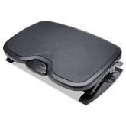

***Item:*** *KMW52789*

* Reduce muscle strain and fatigue by supporting your legs at an optimum angle.
* Angle adjusts and locks into place with a simple press of the foot.
* Non-skid surface.
* Reduces pressure on your lower back when set to your SmartFit personal comfort color.

https://www.wbmason.com/ProductDetail.aspx?ItemID=KMW52789&uom=EA&COID=&SearchID=224035682&ii=2

### Fellowes® Standard Footrest, Adjustable, 17 5/8w x 13 1/8d x 3 3/4h, Graphite, $27.19

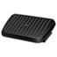

***Item:*** *FEL48121*

* Free-floating platform that encourages lower leg movement to help reduce fatigue.
* Dual-position height adjustment.
* Textured surface massages soles of feet.

Recycled Item

https://www.wbmason.com/ProductDetail.aspx?ItemID=FEL48121&uom=EA&COID=&SearchID=224034215&ii=1

### Fellowes® Adjustable Locking Footrest w/Microban, 17 1/2 x 13 1/8 x 5 5/8, Black/Silver, $80.09

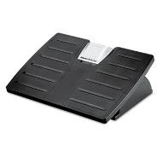

***Item:*** *FEL8035001*

* Footrest adjusts using foot pressure.
* No bending or stooping required.
* Locking mechanism either holds the footrest in position or allows you to rock back and forth.
* Three different height settings and 30 forward or back tilt.

https://www.wbmason.com/ProductDetail.aspx?ItemID=FEL8035001&uom=EA&COID=&SearchID=224036854&ii=5

**LUMBAR/SEAT CUSHIONS:**

### ObusForme® Highback Backrest Support

***Item:*** *75333*

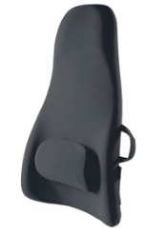

* Extended head and neck section provides additional comfort, support, and protection
* Increases comfort, reduces back pain by aligning spine and supporting correct posture
* Removable, adjustable lumbar support pads provides additional comfort for the lower back
* Ideal for people who spend long hours driving
* **ObusForme® Highback Backrest Support** Extended head and neck section provides additional comfort, support, and protection. Durable polyurethane foam provides cushy comfort. Patented polycarbonate S-shaped frame conforms to contours of the back. It comes with a removable lumbar pad for additional lower back support or for use as a head and neck rest.
* Lightweight for easy transport. Includes removable lumbar pad for added lower back support. Three layers of durable polyurethane foam provides cushy comfort and surrounds the frame. The non-allergenic, brushed nylon cover can be removed and sponge washed.
* This is the perfect backrest support for those who spend long hours driving. Patented and award winning, ObusForme backrest supports are noted for their effectiveness in reducing back pain and encouraging proper spine alignment. Black.
* 18"W x 31"H x 5-1/2"D
* WARNING: This product can expose you to chemicals including DI(2-ETHYLHEXYL) PHTHALATE (DEHP), which is known to the State of California to cause cancer and birth defects or other reproductive harm. For more information go to [www.P65Warnings.ca.gov](https://www.p65warnings.ca.gov/).

<https://www.alimed.com/obus-forme-highback-backrest-support.html>

### ObusForme® Lowback Backrest Support

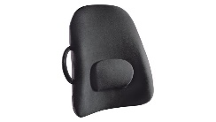

***Item:*** *75335*

* Patented and award winning
* Well known for its effectiveness in reducing back pain by encouraging proper spine alignment
* Removable, adjustable lumbar support provides additional lower back support
* Hypoallergenic and sponge washable
* ObusForme's "flagship" backrest product. The Lowback is lightweight and portable. Patented S-shaped frame. Includes removable lumbar pad for added lower back support. Relaxes muscles, leaving you more comfortable and energized.
* Patented and award winning, ObusForme is well known for its effectiveness in reducing back pain and encouraging proper spine alignment. Durable polyurethane foam provides cushy comfort. Features molded, impact resistant, lighweight polycarbonate frame. Covered with hypoallergenic, brushed nylon, all ObusForme backrests are sponge washable. Use ObusForme backrest supports virtually anywhere-at home, in the office, or in the car. Black.
* 18"W x 21"H x 5-1/2"D
* WARNING: This product can expose you to chemicals including DI(2-ETHYLHEXYL) PHTHALATE (DEHP), which is known to the State of California to cause cancer and birth defects or other reproductive harm. For more information go to [www.P65Warnings.ca.gov](https://www.p65warnings.ca.gov/).

<https://www.alimed.com/obus-forme-lowback-backrest-support-15352.html>

### AliMed® T-Foam™ Lumbar Support

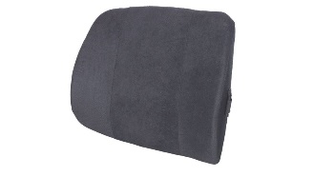

***Item:*** *62231*

* Anatomically contoured to conform to your body while helping to maintain the natural curve of your spine
* Helps prevent and relieve lower back pain
* Unparalleled support and resiliency

https://www.alimed.com/_resources/common/userfiles/image/MadeinUSA_118X19.jpg

* **AliMed® T-Foam™ Lumbar Supports** help prevent and relieve lower back pain. Anatomically contoured to conform to the body, while helping maintain the natural curve of the wheelchair user's spine. T-Foam memory foam offers uniform support without the "pushback" of conventional foam. Curved back fits sling-backed wheelchairs. Elastic strap for secure attachment to wheelchair back. Upholstered in removable, washable plush fabric. Available in Navy or Black.
* 14"W x 13"H • Removable, washable plush fabric
* WARNING: This product can expose you to chemicals including DI(2-ETHYLHEXYL) PHTHALATE (DEHP), which is known to the State of California to cause cancer and birth defects or other reproductive harm. For more information go to [www.P65Warnings.ca.gov](https://www.p65warnings.ca.gov/).

<https://www.alimed.com/alimed-t-foam-lumbar-support.html>

**Note: This item also comes in curved back:**

**Contoured Lumbar Cushion, T-Foam, Curved Back, Black**

***Item: 62232***

### Kensington® Memory Foam Backrest, 16"w x 12"d x 16"h, Black, $49.99

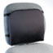

***Item:*** *KMW82025*

* High-density memory cell foam was originally developed by NASA to relieve G-force strain during lift off.
* Easy-to-adjust straps fit almost any chair.
* Removable and washable fabric cover stays cleaner longer.
* Temperature- and pressure-sensitive, it molds to the body's contour, offering optimal comfort and back support.

<https://www.wbmason.com/ProductDetail.aspx?ItemID=KMW82025&uom=EA&COID>=

### AliMed® T-Foam™ Seat Cushion and Seat Wedge

***Item:*** *74581*

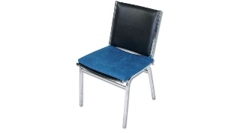

* Reduces pressure on thighs and buttocks

https://www.alimed.com/_resources/common/userfiles/image/MadeinUSA_118X19.jpg

* **AliMed® T-Foam™ (Temper Foam®) Seat Cushion** reduces pressure on thighs and buttocks. Slopes down toward the chair's back, forcing the user's pelvis to collapse backwards. Upholstered in high-quality, plush navy fabric. 18"W x 16"L x 1" thick.
* AliMed® T-Foam™ (Temper Foam) Seat Wedge maintains the natural "S" curve of the spine. Corrects position of pelvis, giving you better posture. Upholstered in high-quality, plush navy fabric. 18"W x 16"L x 3" thick (at rear). For savings order in combination with the Lumbar Support and maximize posture and seating comfort.
* WARNING: This product can expose you to chemicals including DI(2-ETHYLHEXYL) PHTHALATE (DEHP), which is known to the State of California to cause cancer and birth defects or other reproductive harm. For more information go to [www.P65Warnings.ca.gov](https://www.p65warnings.ca.gov/).

***Seat wedge Item:*** *74582*

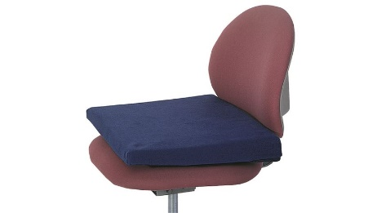

<https://www.alimed.com/t-foam-seat-cushion-and-seat-wedge.html>

### ObusForme® Seat

***Item:*** *75339*

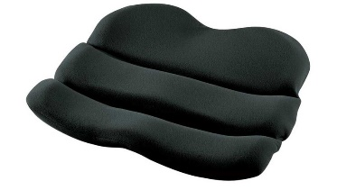

* Offers firm, flexible support
* Evenly distributes body weight, eliminating pressure points
* ObusForme® Patented and award winning, ObusForme backrest supports are noted for their effectiveness in reducing back pain and encouraging proper spine alignment.
* Use ObusForme support virtually anywhere - at home, in the office, or in the car. Covered with hypoallergenic, brushed nylon, all ObusForme backrests are sponge washable.
* The OBUS SEAT offers firm, flexible support. Evenly distributes body weight, eliminating pressure points. Pelvis and hips are comfortably supported by contoured sides. Can be used alone or with any ObusForme backrest. Black.
* 17"W x 18"H x 3-1/2"D
* WARNING: This product can expose you to chemicals including DI(2-ETHYLHEXYL) PHTHALATE (DEHP), which is known to the State of California to cause cancer and birth defects or other reproductive harm. For more information go to [www.P65Warnings.ca.gov](https://www.p65warnings.ca.gov/).

<https://www.alimed.com/obus-forme-seat-15353.html>

### Stratta Mesh-Chair Seat Cushion

***Item:*** *711721*

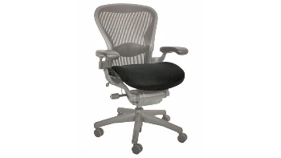

* Premium high-density foam seat cushion designed for Herman Miller Aeron mesh office chairs
* Easy to slip on cushion fits snuggly over the seat
* Comfortably retrofit your Aeron or other mesh office chair

https://www.alimed.com/_resources/common/userfiles/image/MadeinUSA_118X19.jpg

* Restore Life and Add Comfort To Your Mesh Office Chair Seat
* **The Stratta Mesh Chair Seat Cushion by Bodybilt®** Retrofit your Herman Miller Aeron or other mesh office chair with this comfortable high-density foam seat cushion. Not only does this specially designed chair cushion increase Aeron seat comfort, it also reduces instances of clothing fabric pulls. Foam Seat Cushion slips on easily. Made with environmentally friendly BioFlex™ Hybrid soy-based foam. Sized to fit many popular mesh office chair seats. Cushion height is 2".
* Regular/Large Mesh Office Chair Cushion Dimensions: 18-1/2"W x 19"D
* X-Large Mesh Office Chair Cushion Dimensions: 19-1/2"W x 21"D
* WARNING: This product can expose you to chemicals including DI(2-ETHYLHEXYL) PHTHALATE (DEHP), which is known to the State of California to cause cancer and birth defects or other reproductive harm. For more information go to [www.P65Warnings.ca.gov](https://www.p65warnings.ca.gov/).

https://www.alimed.com/stratta-mesh-chair-seat-cushion.html

**GLARE/PRIVACY SCREENS:**

### 3M™ Antiglare Executive Flat Frame Monitor Filter, 16"-19" CRT/17"-18" LCD, $123.69

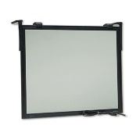

***Item:*** *MMMEF200XLB*

* Excellent glare reduction.
* Flat frame design.
* Includes both LCD and CRT hanger arms.
* Easy to clean.

### <https://www.wbmason.com/ProductDetail.aspx?ItemID=MMMEF200XLB&uom=EA&COID=&SearchID=224041152&ii=12>

### 3M™ Antiglare Flatscreen Frameless Monitor Filters for 19" Widescreen LCD Monitor, $62.59

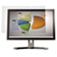

***Item:*** *MMMAG190W*

* Helps reduce glare and mirror-like reflections which makes your screen easier to use in high-glare situations.
* Compatible with most touchscreen displays.
* Easy-to-apply; removable and re-attachable.
* Includes two forms of attachment strips.

### <https://www.wbmason.com/ProductDetail.aspx?ItemID=MMMAG190W&uom=EA&COID=&SearchID=224047659&ii=86>

### 3M™ Framed Desktop Monitor Privacy Filter for 18.1"-19 LCD/19 CRT, $175.69

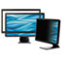

***Item:*** *MMMPF319*

* Darkens on-screen images for anyone viewing the screen from the side.
* User sees clearly with no blurring or distortion.
* Reduces screen glare up to 98%.
* Command attachment system or use optional hanger arms.

### <https://www.wbmason.com/ProductDetail.aspx?ItemID=MMMPF319&uom=EA&COID=&SearchID=224045532&ii=7>

### 3M™ Framed Desktop Monitor Privacy Filter for 20"-20.1" Widescreen LCD, 16:9, $193.49



***Item:*** *MMMPF320W*

* Darkens on-screen images for anyone viewing the screen from the side.
* User sees clearly with no blurring or distortion.
* Reduces screen glare up to 98%.
* Command attachment system or use optional hanger arms.
* Choice of two easy-to-use attachment methods - 3M Command adhesives and hanger arms
* One year warranty from date of purchase
* High quality proudly made in the USA

### <https://www.wbmason.com/ProductDetail.aspx?ItemID=MMMPF320W&uom=EA&COID=&SearchID=224039706&ii=1>

### 3M™ Framed Desktop Monitor Privacy Filter for 23.6"-24 Widescreen LCD, 16:10, $239.99

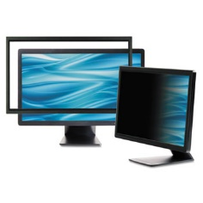

***Item:*** *MMMPF324W*

* Darkens on-screen images for anyone viewing the screen from the side.
* User sees clearly with no blurring or distortion.
* Reduces screen glare up to 98%.
* Command attachment system or use optional hanger arms.

### <https://www.wbmason.com/ProductDetail.aspx?ItemID=MMMPF324W&uom=EA&COID=&SearchID=224043855&ii=10>

**SIT/STAND DESKS:**

### Pro 36, $395

### Pro 36 VARIDESK Standing Desk Black

### <https://www.varidesk.com/products/height-adjustable-desk-pro?o=Size:36%20inch;Color:Black>

### Pro Plus 36, $395

# **Pro Plus™ 36**

## **Turns any desk into a standing desk**

# **Pro Plus™ 36**

## **Turns any desk into a standing desk**

# **Pro Plus™ 36**

## **Turns any desk into a standing desk**

# **Pro Plus™ 36**

## **Turns any desk into a standing desk**

# **Pro Plus™ 36**

## **Turns any desk into a standing desk**

### Pro Plus 36 Black Best Seller

### https://www.varidesk.com/products/standing-desk-pro-plus?o=Size:36%20inch;Color:Black

### Humanscale QuickStand, Start at $879

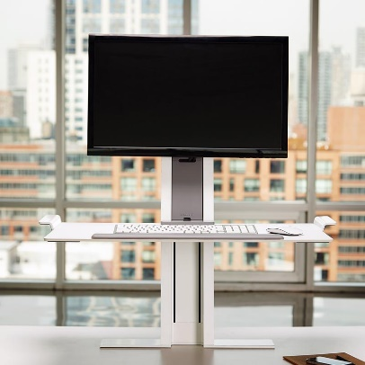

### <https://www.humanscale.com/products/product.cfm?group=quickstand>

### Humanscale Float, Start at $1799

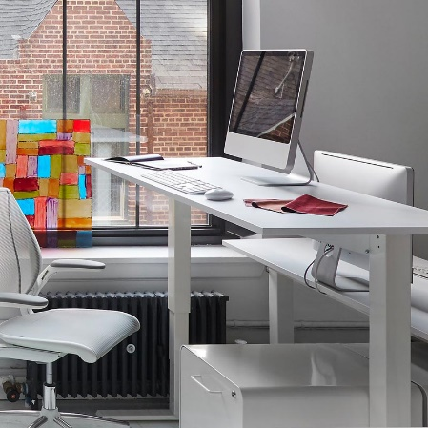

### <http://www.humanscale.com/products/product_detail.cfm?group=float>

### STEELCASE

### Airtouch Adjustable Height Desk, Starts at $1257.15 (other retailers)

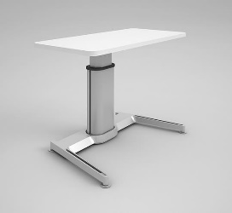

### <https://www.steelcase.com/asia-en/products/desks/airtouch/>

**MONITOR ARMS:**

### Humanscale M2 ® MONITOR ARM, Starts at $259

### https://www.humanscale.com/userFiles/images/monitorarms/m2/m2_thumb.jpg

### <https://www.humanscale.com/products/product.cfm?group=M2>

### Humanscale M8 MONITOR ARM, Starts at $399

### https://www.humanscale.com/userFiles/images/monitorarms/m8/m8_thumb.jpg

### <https://www.humanscale.com/products/product.cfm?group=m8>

### Humanscale M8 CROSSBAR, Starts at $499

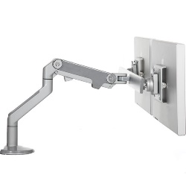

### <https://www.humanscale.com/products/product.cfm?group=m8monitorarm>