Graduate Tutoring in MLC, JEN 218 Fall 2020
Drop-in, no appointment needed; online or in-person (in JEN 220)

GR 521: Mo 12:30 – 8; Tu 12:30 – 8; We 12:30 – 8; Th 12:30 – 7

ST 625: Mo 12:30 – 8; Tu 12:30 – 2, 3:20 – 8; We 1:50 – 8; Th 12:30 – 7

Zoom ID-s
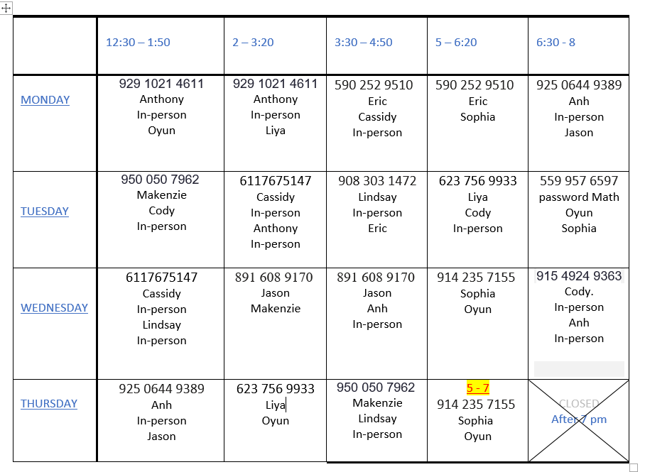
There could be temporary changes, due to tutors occasionally switching shifts.

