CMT – InDesign Tutorial

Adobe InDesign is a software that is a part of Adobe’s Creative Suite. It is a desktop publishing and typesetting software that is typically used to create layouts for works such as posters, flyers, brochures, magazines, newspapers, presentations, books and ebooks. Adobe provides comprehensive tutorials for their InDesign tools. Refer to the following link to access these: https://helpx.adobe.com/indesign/tutorials.html
This tutorial summarizes the basic tools that form the framework for starting a new project within Adobe InDesign. Please refer to the following website for an accompanying video tutorial: https://www.bentley.edu/centers/cmt/tutorial. Feel free to email us at ga_cmt@bentley.edu for questions and assistance.

CREATING A NEW DOCUMENT
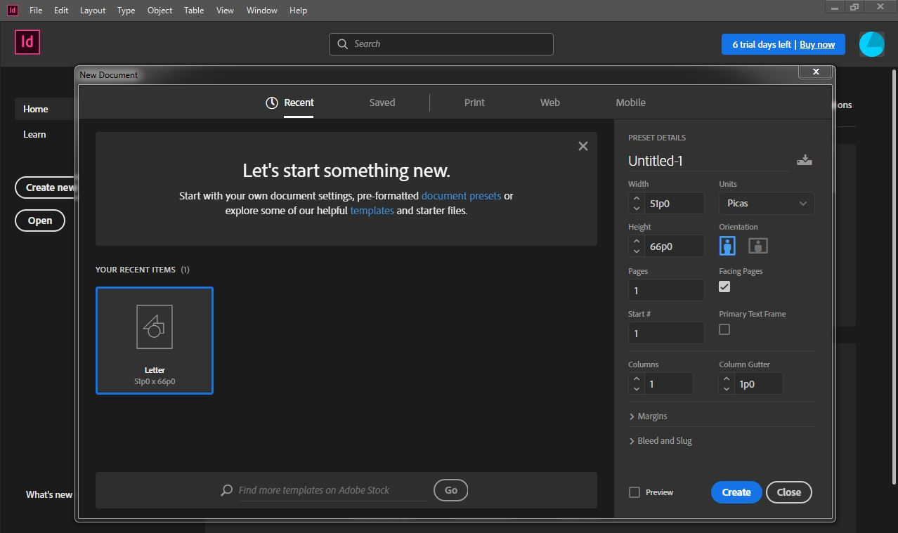
When opening InDesign for the first time, you have the option of either ‘Open’ or ‘Create New’. When you click ‘Create New’, you will be brought to the following window:

Modify each of the cells as needed. The important fields are highlighted below:
- Units: The dropdown contains options for the unit system that you prefer to work in. These include the default picas, inches, millimeters, centimeters, etc. Once you set this up, all remaining cells will change to the selected unit. For example, if you select inches, the Width, Height, Column Gutter, etc. will display its values in inches.
- Width/ Height: Corresponds to the width and height of individual pages.
- Orientation: Portrait or Landscape
- Pages: Number of pages in the document. You can add more while creating the document as needed.
- Facing Pages: This option should be checked if you are creating a document like a book or a magazine that has two pages arranged together as a spread. For documents like resumes or flyers, the facing pages option is typically not checked.
- Margins: The width of the margins desired along all four edges of your page.
- Bleed & Slug: The bleed option will have a value assigned if you anticipate having images within your document that ‘bleed’ to the edge of the sheet, i.e. extend to the edge of the paper with no white space visible around it. This dimension is different based on where you will get your document printed, but the typical dimension is 1/8”.
The slug option sets up a space around your document for any non-printing information that you may want to include such as the date or the title. This information is only visible to you while editing but will not be printed.
Once you have all your fields set to the desired values, click ‘Create’. You will be brought to the editing interface of InDesign that will look similar to the screenshot below with variations based on your initial parameters that were set while creating the document.
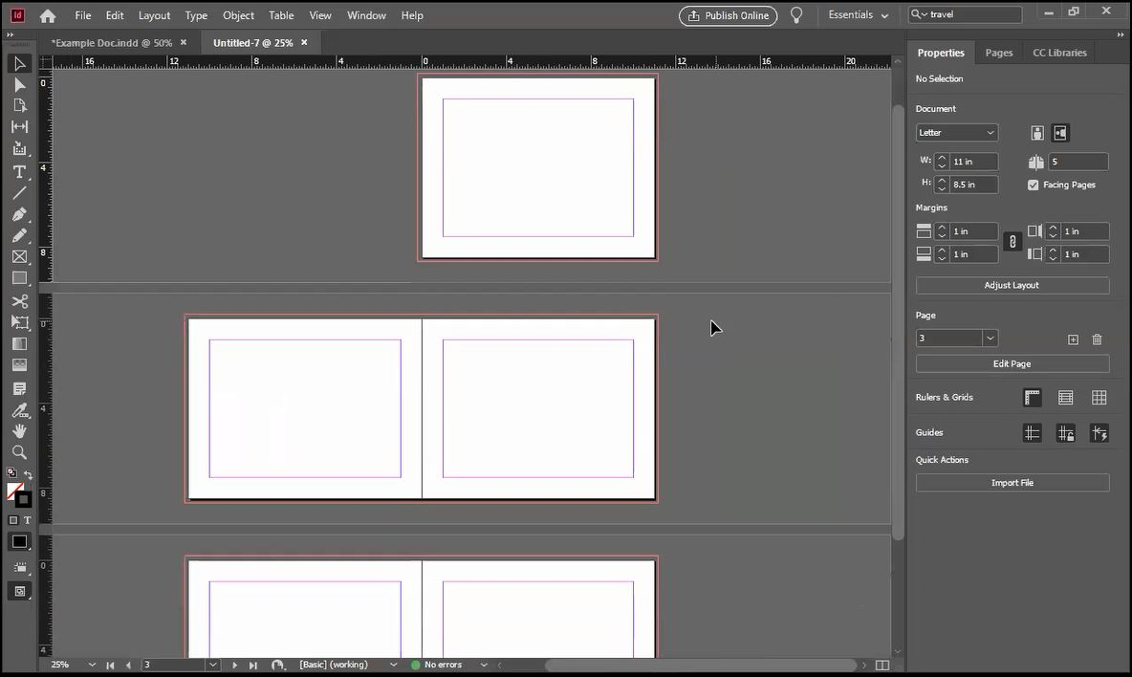
- The red line visible outside the white paper space is the ‘bleed’ line.
- The purplish-pink lines within the white paper space are your margins.
- The screenshot illustrates a document created with facing pages checked. If left unchecked, all the pages would look like the first page with no pages pasted next to each other.

INDESIGN EDITING INTERFACE
1.
2.
3.

- Tool bar: Includes all the typical tools that would be used while editing.
- Ruler: Provides a guide for placing objects, images or grid lines while editing. Right click on either rules on the top or the left to change the unit.
- Docked Panels (Properties/ Pages/ CC Libraries):
Properties: Provides options to change properties of images, objects, etc. For example, if an image on the page is selected, the properties panel will display options to edit the image. If a text box is selected, options to edit the text box will be displayed. If not specific object is selected, options to edit the document and pages will be displayed.
Pages: Displays the master pages and thumbnails of the existing pages to allow for quick navigation within the document. Double click the page you would like to go to.

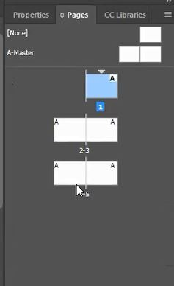

MASTER PAGE
Navigate to the master page/ spread by double clicking the A-Master spread in your Pages panel. You can set up any features that you would like to be uniform throughout your document within the master sheet. For example, if you would like page numbers to be visible throughout your document, set this up in the master. Features that are set up in the master are ‘locked’ on the actual pages within your document and you will not be able to edit them without overriding them.
While the master is automatically applied to the entire document, it is possible to override the master on certain pages. To do so, right click on the page thumbnail that you wish to override master items on, and select ‘Override All Master Page Items’. Once you do this, you will see that master page items are now ‘unlocked’ on that specific page, and you are now able to select and edit them.

GUIDES AND GRID LINES
InDesign provides the Guides tool that allows to create guide lines on your page. These lines can help create uniform formatting and spacing within your document by allowing all objects to snap to them. To create guides, go to the top of your page and click Layout > Create Guides. This will bring you to the window below.
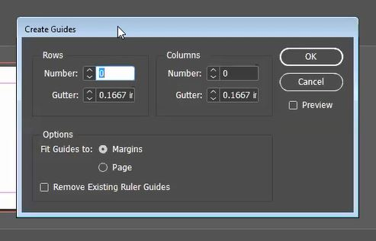

Specify the number of rows and columns you would like created. For example, specifying 2 rows will create 3 guide lines that split your page into two equal rows. The gutter allows you to specify a distance between each guide line.
You have the option to have your guide lines span the entire page or just span between the margins created. Check either option as desired.
Your created guides will be displayed as light blue lines as seen below. The screenshot below shows 6 columns spanning the margin with the default column gutter dimension of 0.1667 inches.
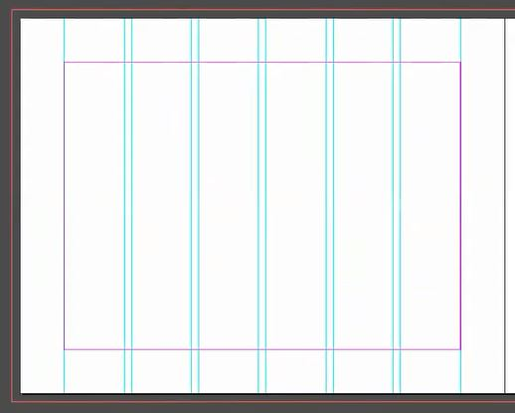

InDesign also has default ‘smart guides’. While dragging any object around on the sheet, automatic pink lines will appear when you snap to the centers of the pages, or if you are aligned with another object on the page, etc.

TYPE TOOL
The Type tool can be accessed on the tool bar to the left of your screen. To insert a block of text, simply select the type tool and then click and drag to create a text box. Double click within the box and start typing.
To move the text box, simply hit escape so that you are not typing within the box anymore, make sure that the text box is selected and drag to your desired location.
To edit the text box, select the text box or the text within your box and make changes using the properties panel to the right of your screen.
To create page numbers throughout your document, create a text box within your master. Once your cursor is blinking within the text box, go to the properties panel on the right side of the screen and click on ‘Insert Special Character’ under Quick Actions. Then click Markers > Current Page Number. When performing this action on your master, a letter, typically ‘A’ will be inserted into the text box since the master is not actually a page within the document. However, you will see that within your actual document, the true page numbers are visible.
To fill your text box with temporary placeholder text, navigate to Fill with Placeholder Text under Quick Actions in the Properties panel while you have the text box selected.

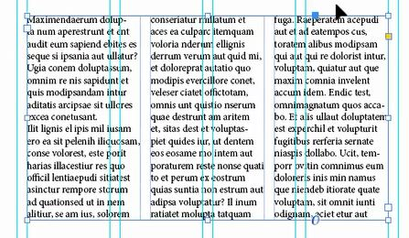
<- To split your text box into different columns of continuous text, right click inside the text box, and click Text Frame Options. Once here, you can specify the number of columns you would like within a single text box.

IMAGES AND FRAMES
In order to insert an image into your document, navigate to File > Place at the top of your page. Once you have selected the image you would like to insert, click anywhere on the page to place it. Once on the page you can resize the image, or even edit the actual image using the properties panel on the right when you have the image selected.
To edit the frame, crop the image or move the frame, make sure the frame is selected. You will know that the frame is selected if the outline is BLUE. If you double click within the blue frame, your cursor will change to a hand and the frame will be ORANGE. The difference between the two colors is that the blue shows you the cropped image, and double clicking will show you the outline of your original uncropped image and allow you to move the uncropped image within the cropped frame.
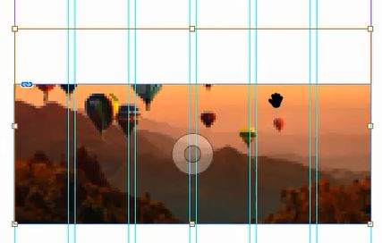

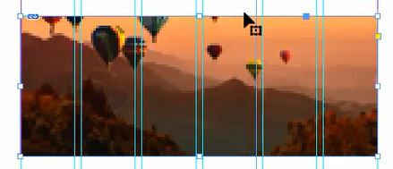
Left: Blue outline with cursor, showing cropped image. Right: Orange outline with hand showing outline of original uncropped image.

DISPLAY PERFORMANCE
InDesign automatically sets the display of any inserted image to ‘typical’. This is the reason why many images appear to be pixelated when placed on the workspace. This is done to prevent any kind of lag due to higher processing powers required to display images at their full quality. To change this setting, go to the top of your screen and click View > Display Performance and select the desired quality.

SAVING AND EXPORTING DOCUMENTS
To save your inDesign document, navigate to File> Save.
To export to a PDF, File > Export and select pdf as your file type. If your document has facing pages/ spreads, make sure that you select ‘Spreads’ under Export As within the window.
