Professor Christine Williams from our Global Studies Department works on a research project about ‘Police Use of Social Media’ and focuses on police tweets discussing COVID19. Her team has collected tweets on #COVID19 from over 2,000 active U.S. police department accounts nationwide.
Five Highlights to date:
- In the U.S. from March 1 to March 10 most (78% of accounts) police departments were not posting about the coronavirus (only 7% of total tweets& retweets were about the virus.
- From March 11 to March 18 Numbers jump to 66.6% of active accounts posted and represent 25% of total tweets
- Police are proportionally retweeting external sources on this crisis far more than they retweet about other topics. The network analysis shows that CDC is most retweeted source, federal government rarely except for FBI, other retweeted sources are governors/mayors.
- The re-tweets of virus-related tweets are being retweeted by the general population much more than re-tweets of non-covid-19 related tweets
- The top 5 (in volume) police department accounts tweeting virus related are in FL, FL, MA, PA, MD (so top 2 are in Florida). Interesting to note that these are not the hardest hit states.
This research project is co-sponsored by the Valente Center for Arts & Sciences. Professor Christine Williams’ team included Valente Center Research Assistant, Nathan Duplessis, Jane Fedorowicz, Professor of Accountancy and Information & Process Management, Kevin Mentzer, Professor of Information Systems and Analytics at Bryant University and Graduate Assistant, Hui Luo.
Nathan says “I am excited to be embarking on this project with Professor Williams, Professor Fedorowicz, and Professor Mentzer. I have been involved with collecting data and articles about police use of social media. I am researching timelines on major US virus events so that we can track the milestones of the outbreak and map them to the trend in tweets from police departments nationwide. I benefit from getting first-hand experience on a research project with nationally acclaimed researchers and professors that is not only timely, but an event that will go down in history. Pandemics are an issue that our world will always have to confront, and that is why it is important to learn as much as we can about COVID-19 at this present time. The research that we do now will help us understand and confront other pandemics in the future."
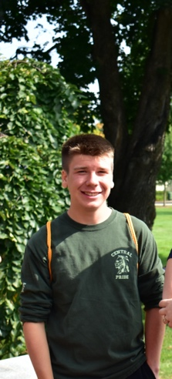
Nathan Duplessis is a sophomore honors student at Bentley University majoring in Accountancy. He is Vice President of the Sophomore Class Cabinet, and a volunteer at Saint Mary’s After School Program in Waltham. Nathan transferred to Bentley from Saint Anselm College last fall. He is originally from New Hampshire, but has really enjoyed making Bentley and the Boston region his new home.

