**Never plug one power strip into another power strip. This is called daisy chaining and could lead to an overload of the electrical outlet and cause an electrical fire.**

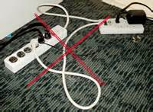

**INCORRECT POWER STRIP (Surge protector)**

***No*** auto shutoff light! Just an on/off switch.

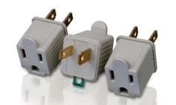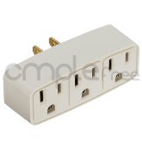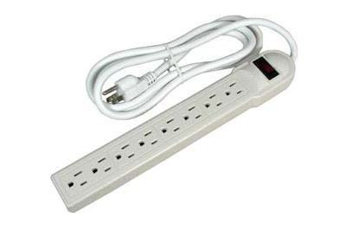 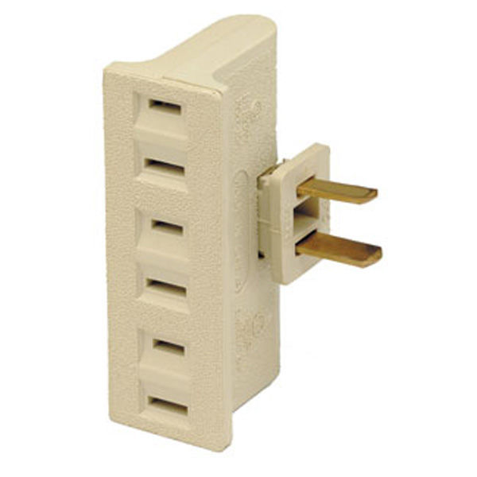

Electrical adapters also need an automatic shutoff light.

**No extension cords are allowed!**

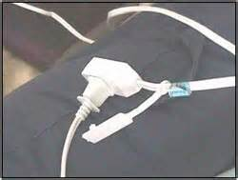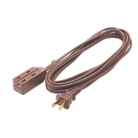

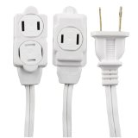

**CORRECT POWER STRIP (Surge protector)**

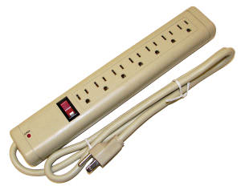

**Auto Shutoff** !

Can be any color…red, green, blue, yellow, orange. This signifies it’s an auto shutoff.

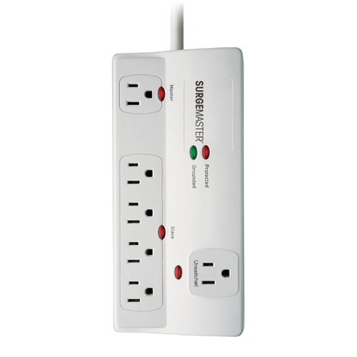

**Auto Shutoff!**