Welcome to the Stress Management Workshop!

This workshop is for students who would like more options in how to manage stress. This workshop is a friendly place to talk about stress in your life and learn new ways to manage it.

Topics that we will cover:
• Identifying stress
• Managing stress
• Reducing the impact of stressful situations

As a group, each week we will cover one of the topics mentioned above. The goal is for students to feel more confident in their ability to tolerate stress (from school, family, relationships, sports, etc.) by taking what you learn in the workshop and applying it to your everyday lives!

At the beginning of the workshop, students will introduce themselves briefly and check-in about how they are doing (less than five minutes) before reviewing the homework. The topic of the week will then be introduced, including practice exercises. The end of workshop will have an opportunity for members to check in about how the session went.

In order for everyone to get the most out of this workshop, we ask that you agree to:

- All group members agree to respect the confidentiality of the group and not discuss information outside of group.
- To maintain a comfortable environment, it is important to be respectful to each other, as we each may have unique values and beliefs. All members are also asked to refrain from using judgmental language, language based on cultural or racial differences, gender, sexual orientation, etc. Disruptive or threatening behavior is also not permitted.
- All cell phones must be turned off during group, or kept out of sight.
- Group is focused on practicing present-focused coping skills. People are welcome to share and conversations will be re-directed back to skills.
- If you are feeling unsafe during group, let us know immediately. If you have a potential crisis or need immediate assistance, particularly at night or on weekends, please call Campus Police Emergency line: (781) 891-3131

Week One: Identifying Stress

Today’s Agenda:
- Introduction to the Workshop
- Check-in
- Identifying Stress
- Discussion of Stress
- Stress Inventory
- Diaphragmatic Breathing Exercise
- Progressive Muscle Relaxation Exercise
- Guided Visualization

Today’s Packet includes:
- Blank Stress Diagram
- College Stress Information Sheet
- Stages of Stress Handout
- Stress and Performance Graph
- Physical Reaction to Stress Handout
- List of Stressors
- Diaphragmatic Breathing Exercise Handout
- Progressive Muscle Relaxation Exercise Handout
- Guided Visualization
- Recommended Apps for Coping with Stress
- Homework

Body
Mind
Behavior
Emotion

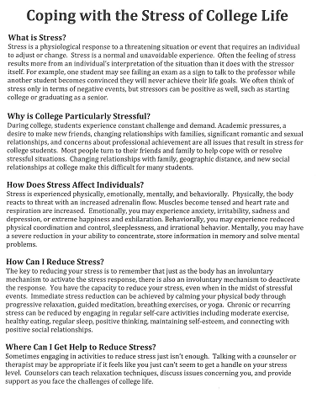

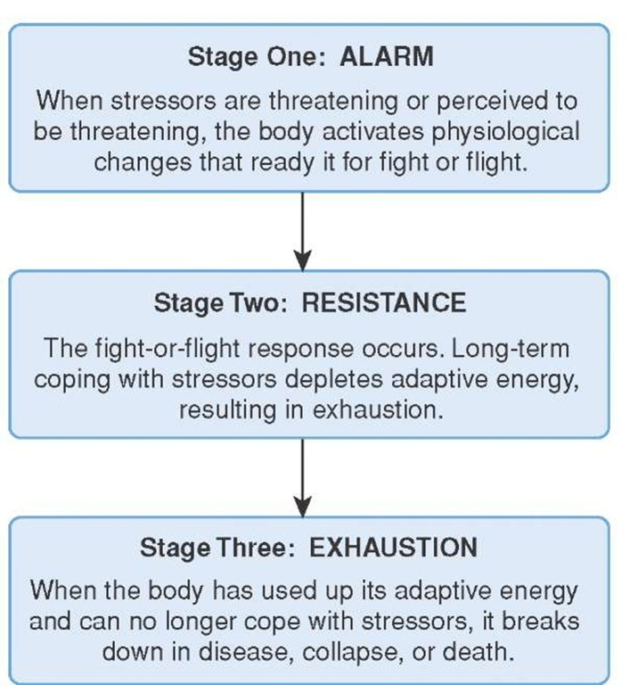

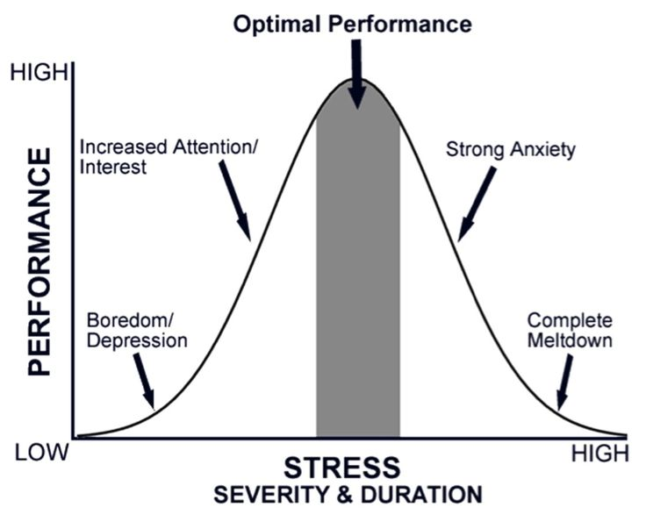

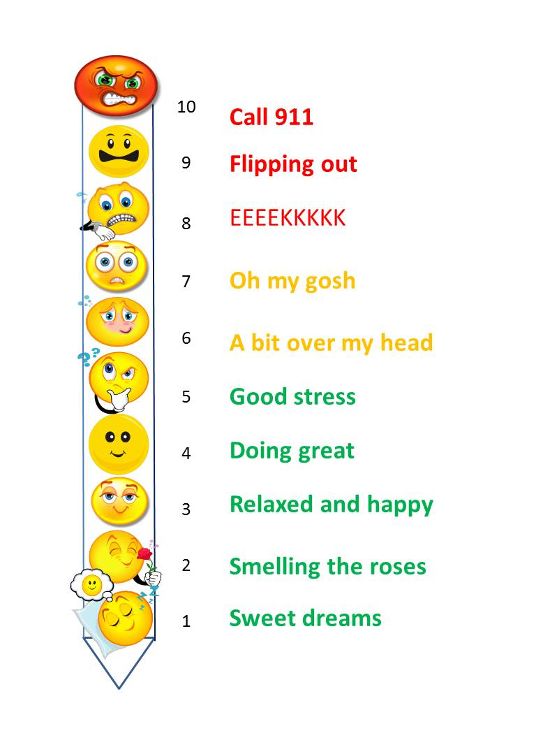
Stress Thermometer

List of Stressors
Ending a relationship
Divorce (self or within family)
Marital Separation (self or family)
Imprisonment/legal issues
Death of someone close
Death of a family member
Personal injury or illness
Marriage
Getting fired
Marital reconciliation
Change in health of family member
Pregnancy
Sexual difficulties
Gain a new family member
Financial difficulties
Change in frequency of arguments
Change in responsibilities at work
Trouble with in-laws/partner’s parents
Outstanding personal achievement
Christmas/major holidays

Begin or end school
Changing in living conditions
Trouble with boss
Change in working hours or conditions
Arguments with your roommate
Final year or first year in college
Beginning a new job
Major disagreements with your family
Problems with your professor
Failure in some course
Final exams
Increased or decreased dating
Changes in your major
Change in your sleeping habits
Several-day vacation
Change in eating habits
Family reunion
Change in recreational activities
Minor violations of the law
Any interpersonal problems

PRACTICE: Abdominal Breathing Technique

Abdominal breathing is designed to intentionally increase the air flow into your lungs to help your body relax. Relaxing our body helps us relax our mind and may reduce the intensity of our current emotional experience.

Take a seat with your feet on the floor and your back against the chair. You can choose to keep your eyes opened or closed. If you keep your eyes opened, rest them gently on something.
Place one hand on your abdomen. When you take a deep breath in, the hand on the abdomen should rise.
Take a slow deep breath in through your nose for 6 seconds. Notice how it feels to have air move through your nose, fill up your lungs, and expand your abdomen.
Slowly exhale through your mouth for a count of 8. As all the air is released, gently contract your abdominal muscles to completely evacuate the remaining air from your lungs. It is important to remember that we deepen respirations not by inhaling more air but through completely exhaling it.
Repeat the cycle four more times for a total of 6 deep breaths and try to breathe at a rate of one breath every 10 seconds (or 6 breaths per minute). At this rate our heart rate variability increases which has a positive effect on cardiac health.
As you focus on your breath, you may notice your mind wander. Gently and nonjudgmentally bring your mind back each time it wanders.
Once you feel comfortable with this, you may want to incorporate words that can enhance the exercise. Examples would be to say the word ‘relaxation’ (when you inhale) and stress or anger (when you exhale). The idea being to bring in the feeling/emotion you want with inhalation and release those you don’t want with exhalation.
Once you have completed the exercise, take a deep breath, slowly open your eyes, and allow yourself to return to the present moment. Notice how your body feels. Now move your attention from your body to the external world. Look around, and return to what you were doing.

PRACTICE: PROGRESSIVE MUSCLE RELAXATION (PMR)

Progressive muscle relaxation is an exercise that relaxes your mind and body by progressively tensing and releasing muscles throughout your entire body. You will tense each muscle group (without straining) for 5 seconds, and then release the tension and notice the muscle relax. If you have any pain or discomfort with a muscle, feel free to omit that step. Throughout this exercise, you may visualize the muscles tensing and a wave of relaxation flowing over them as you release that tension. Remember to keep breathing throughout the exercise.

Begin by finding a comfortable position. Allow your attention to focus on your body. If your minds begins to wander, gently bring it back to the muscle you are working on.
Take a deep breath and notice the feeling of air filling your lungs. Hold your breath for 3 seconds. Release your breath slowly and let the tension leave your body.
Take another deep breath and hold it. Again, slowly release the air.
Take another deeper breath. Fill your lungs and hold the air. Slowly release the breath and imagine the tension leaving your body.
Move your attention to your feet. Begin to tense your feet by curling your toes and arching your feet. Hold onto the tension for 5 seconds and notice what it feels like.
Release the tension in your foot. Notice the new feelings of relaxation.
Now flex your feet, pulling your toes towards you and feeling the tension in your calves. Hold for 5 seconds and release, feeling the weight of your legs sinking down.
Tighten your thighs by pressing your knees together as if you were holding a penny between them. Hold them for 5 seconds, and release.
Gently arch your lower back. Hold for 5 seconds, and then release.
Tighten the muscles in your stomach by sucking in. Hold for 5 seconds and then release.
Tighten your chest by taking a deep breath in, hold for 5 seconds, and then release, blowing out all the tension.
Tense your upper back by pulling your shoulder blades together, trying to make them touch. Hold for 5 seconds, and release.
Now lift your shoulders up to your ears. Hold for 5 seconds and release, feeling the heaviness.
Tighten your triceps by extending your arms out and locking your elbows. Hold for 5 seconds and then release.
Flex your biceps. Feel the tension buildup. Hold for 5 seconds and release.
Tightly clench your fists. Hold for 5 seconds and release.
Gently pull your head back, looking at the ceiling. Hold for 5 seconds and then release.
Tighten your eye muscles by squinting your eyelids shut. Hold for 5 seconds and then release.
Smile widely, feeling your mouth and your cheeks tense. Hold for 5 seconds and then release.
Tighten the muscles in your forehead by raising your eyebrows as high as you can. Hold for 5 seconds and then release.
Now imagine a wave of relaxation slowly spreading through your body beginning at your head and moving down to your feet. Slowly return to the present moment. Open your eyes. Notice how your body feels. Now move your attention from your body to the external world. Look around, and return to what you were doing.

PRACTICE: GUIDED VISUALIZATION

Imagine going to a peaceful place. A place that is safe and secure; one that you feel really good to be in. This might be a place that you’ve actually been to in your life, or it may be a place you’ve visited before in your imagination.
As you settle in, look around and notice what you see. Notice the colors, how bright or dull they are. Notice the objects around you. Notice the presence or absence of people or animals. Notice if there’s movement and, if so, what is moving and where. Notice the stillness.
Notice any sounds in this peaceful place, or whether it’s quiet. What is making noise? What does that noise sound like? Notice what is silent.
Notice whether there’s an aroma or fragrance in the air.
Notice what your body feels physically as it stands, sits, walks, or runs. Notice the sensation of the wind, sun, or rain. Notice the temperature and the time of day. Notice the season of the year.
Notice anything that you might taste.
Notice any feelings any peacefulness, or relaxation, or comfort and allow them to be there. Allow yourself to relax into them. Find the spot where you feel most comfortable and allow yourself to get settled there. Simply enjoy a few quiet moments. Peaceful, relaxed, nothing to do, nowhere to go, enjoying the beauty and the safety. As you deeply relax you can allow your body to recharge and your mind as well – even your spirit.

And if this is a pleasant experience, you should know that you can come back here and enjoy this anytime of your own choosing, simply by deciding to shift your attention to your inner world, allowing your breathing to get deep and comfortable, and imagining yourself coming to this very beautiful, very peaceful, very quiet place. If your mind should wander or get distracted, simply take another breath or two and refocus your mind back to this quiet place. Let this be your focus of attention for five minutes, or ten minutes, or twenty minutes – whatever period of time is right for you. And then when you decide to bring your attention back to the outer world, as I’ll invite you to do now, allow the images to fade but bring back with you any sense of relaxation, peacefulness, refreshment — a good feeling that comes from taking a little time to find that place of calm, quiet, and peacefulness within you. And know that you can come back and visit this place anytime you choose. Also know that this place is always within you, and that by even remembering it or thinking about it, you can touch into that feeling of calmness, peacefulness, and serenity and bring those qualities more and more into your daily life.

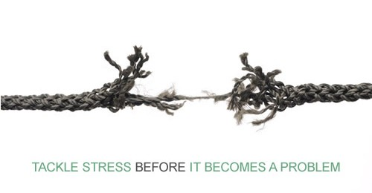
Apps to Help Manage Anxiety and Stress
Worry Watch
Runs on: iPhone
Cost: $1.99
Worry Watch is a journal app designed to help you track and record those everyday anxieties. It aims to provide a deeper understanding of our worry patterns and remind us of how we coped in the past by logging a worry or worries, tracking, analyzing, realizing, and reflecting.
Stop Panic & Anxiety Help
Runs on: Android
Cost: Free
The Stop Panic & Anxiety Help Android app uses emotion and relaxation training audio tracks to help you fight your fears and find a state of calm. When you’ve overcome the attack, use the app’s journal to record what caused the attack and how you were able to get through it. Then use this journal to learn from your experiences and prepare for the future.
Mindshift
Runs on: iPhone
Cost: Free
This app includes strategies to deal with everyday anxiety as well as specific tools to tackle text anxiety, perfectionism, social anxiety, performance anxiety, worry, panic, and conflict.
Pacfica
Runs on: iPhone and Android
Cost: Free
Pacifica is an app for stress, anxiety, and worry based on Cognitive Behavioral Therapy, relaxation, and wellness. Comprised of five core activities, Pacifica is designed as a daily tool to help people address stress and anxiety at a gradual pace.
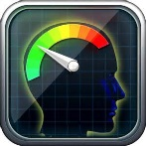
Stress Check
Runs on: Android, iPhone
Cost: Free
Provides users with an overall stress score then the user can examine specific areas their stress affects them (interpersonal, physiological, situational, control).
eCBT Calm
Runs on: iPhone
Cost: $0.99
CBT Calm helps people who are feeling stressed and want to learn relaxation skills. It assesses stress levels, provides relaxation skills, and also provides links to online resources for stress and anxiety

HOMEWORK

We need to make small changes in our thinking and behavior EVERY DAY to more effectively manage stress.

 | Stress Cues
Day | Body | Mind | Emotion | Behavior | Pre-Stress Rating (0-10) | Skill Used | Post-Stress Rating (0-10)

