Week Two: Mindfulness

Today’s Agenda:
- Check-in
- Homework Review
- Benefits of Mindfulness
- Mindfulness
- Mindfulness Practice

Today’s Packet includes:
- Benefits of Mindfulness
- Mindfulness
- RAIN Acronym
- Mindfulness Practice Exercises
- Homework

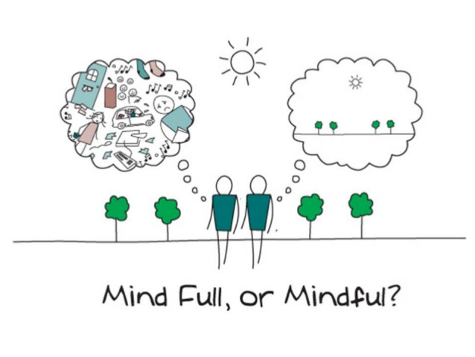

- 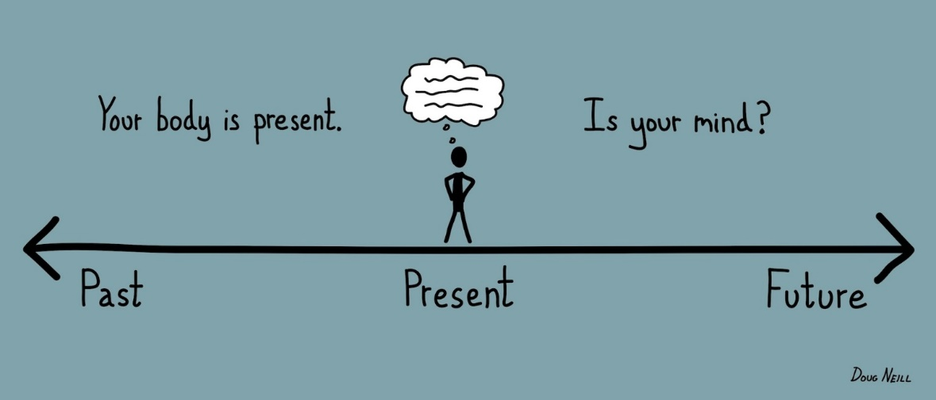
Mindfulness can yield tremendous psychological, emotional and physical health benefits.

But how exactly will mindfulness benefit you?

1. Stability of Mind
Mindfulness benefits include a much more balanced outlook on life, and a state of mind that is less likely to bounce around from one thought to the next.

2. Flexible Awareness
Mindfulness will help train you to take command of your awareness, so that you can shift your attention from depressing or angry thoughts to more positive ones with greater ease.

3. Self-Awareness
Mindfulness trains you to become aware of what is going on inside you and how your inner world of thoughts and feelings is reacting to the events that are taking place in the world around you. When you develop this kind of awareness, you will be more aware of inner disturbances if they arise, and therefore more able to take steps to maintain a positive outlook if they do. Oftentimes, stress and anxiety build up over a period of time because we are not paying attention to what is going on inside us.

4. Non Reactivity
Through mindfulness, and especially through the practice of mindfulness meditation, you learn to observe your thoughts and feelings and any environmental circumstances with a more detached outlook. You learn to stop labelling the events in your life as “bad” or “irritating” or “boring” and so on. Instead, you learn to simply accept things as they are without reacting to them. Of course, this does not mean that you stop working to change the things in your life that problematic for you, but it does mean that you will not be so burdened by problems that you may once have deemed to be intolerable. Non reactivity is summed up nicely by the ever popular “serenity prayer.”

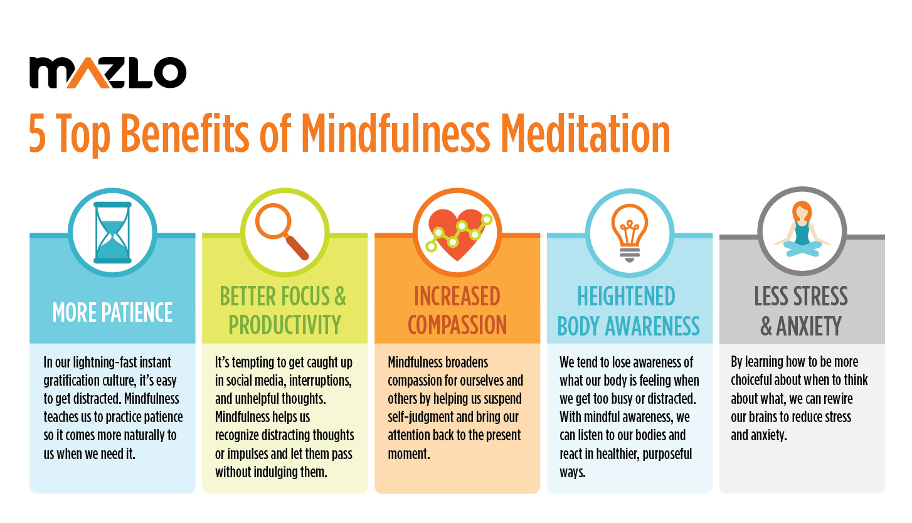

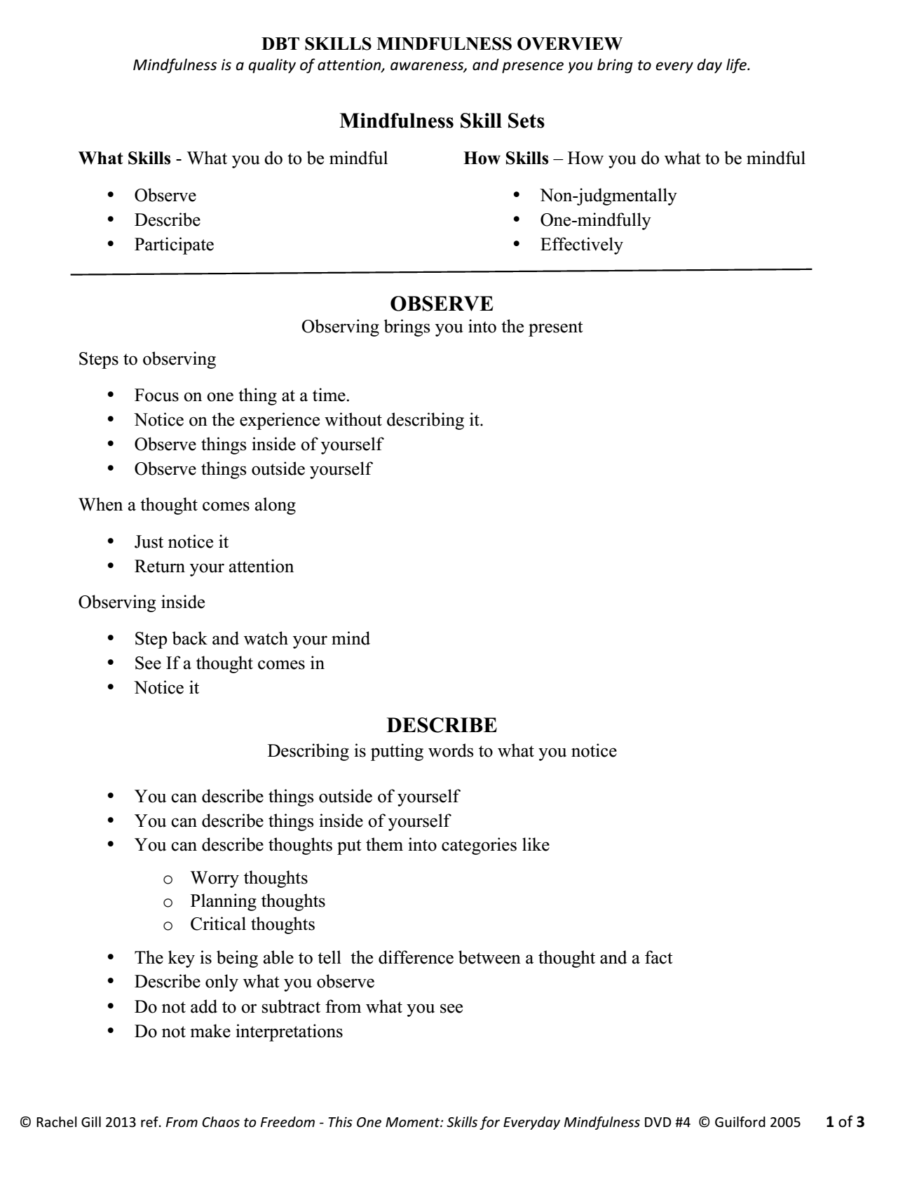
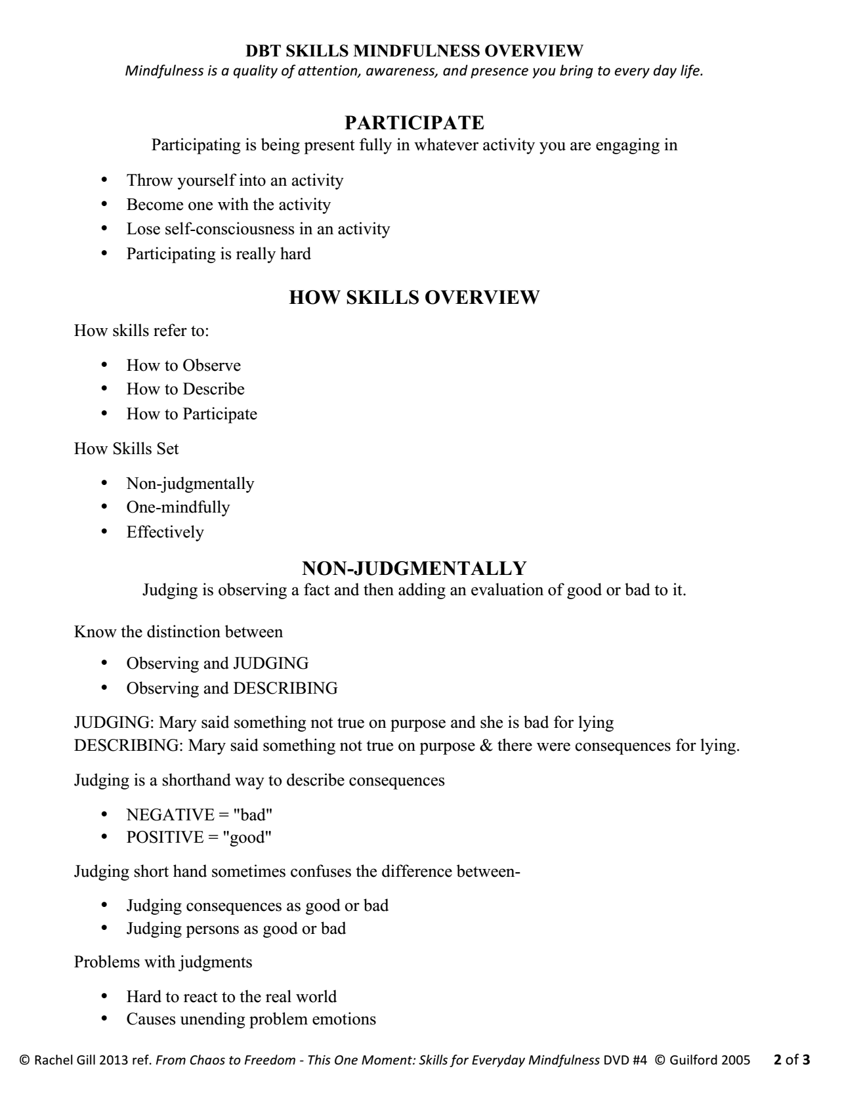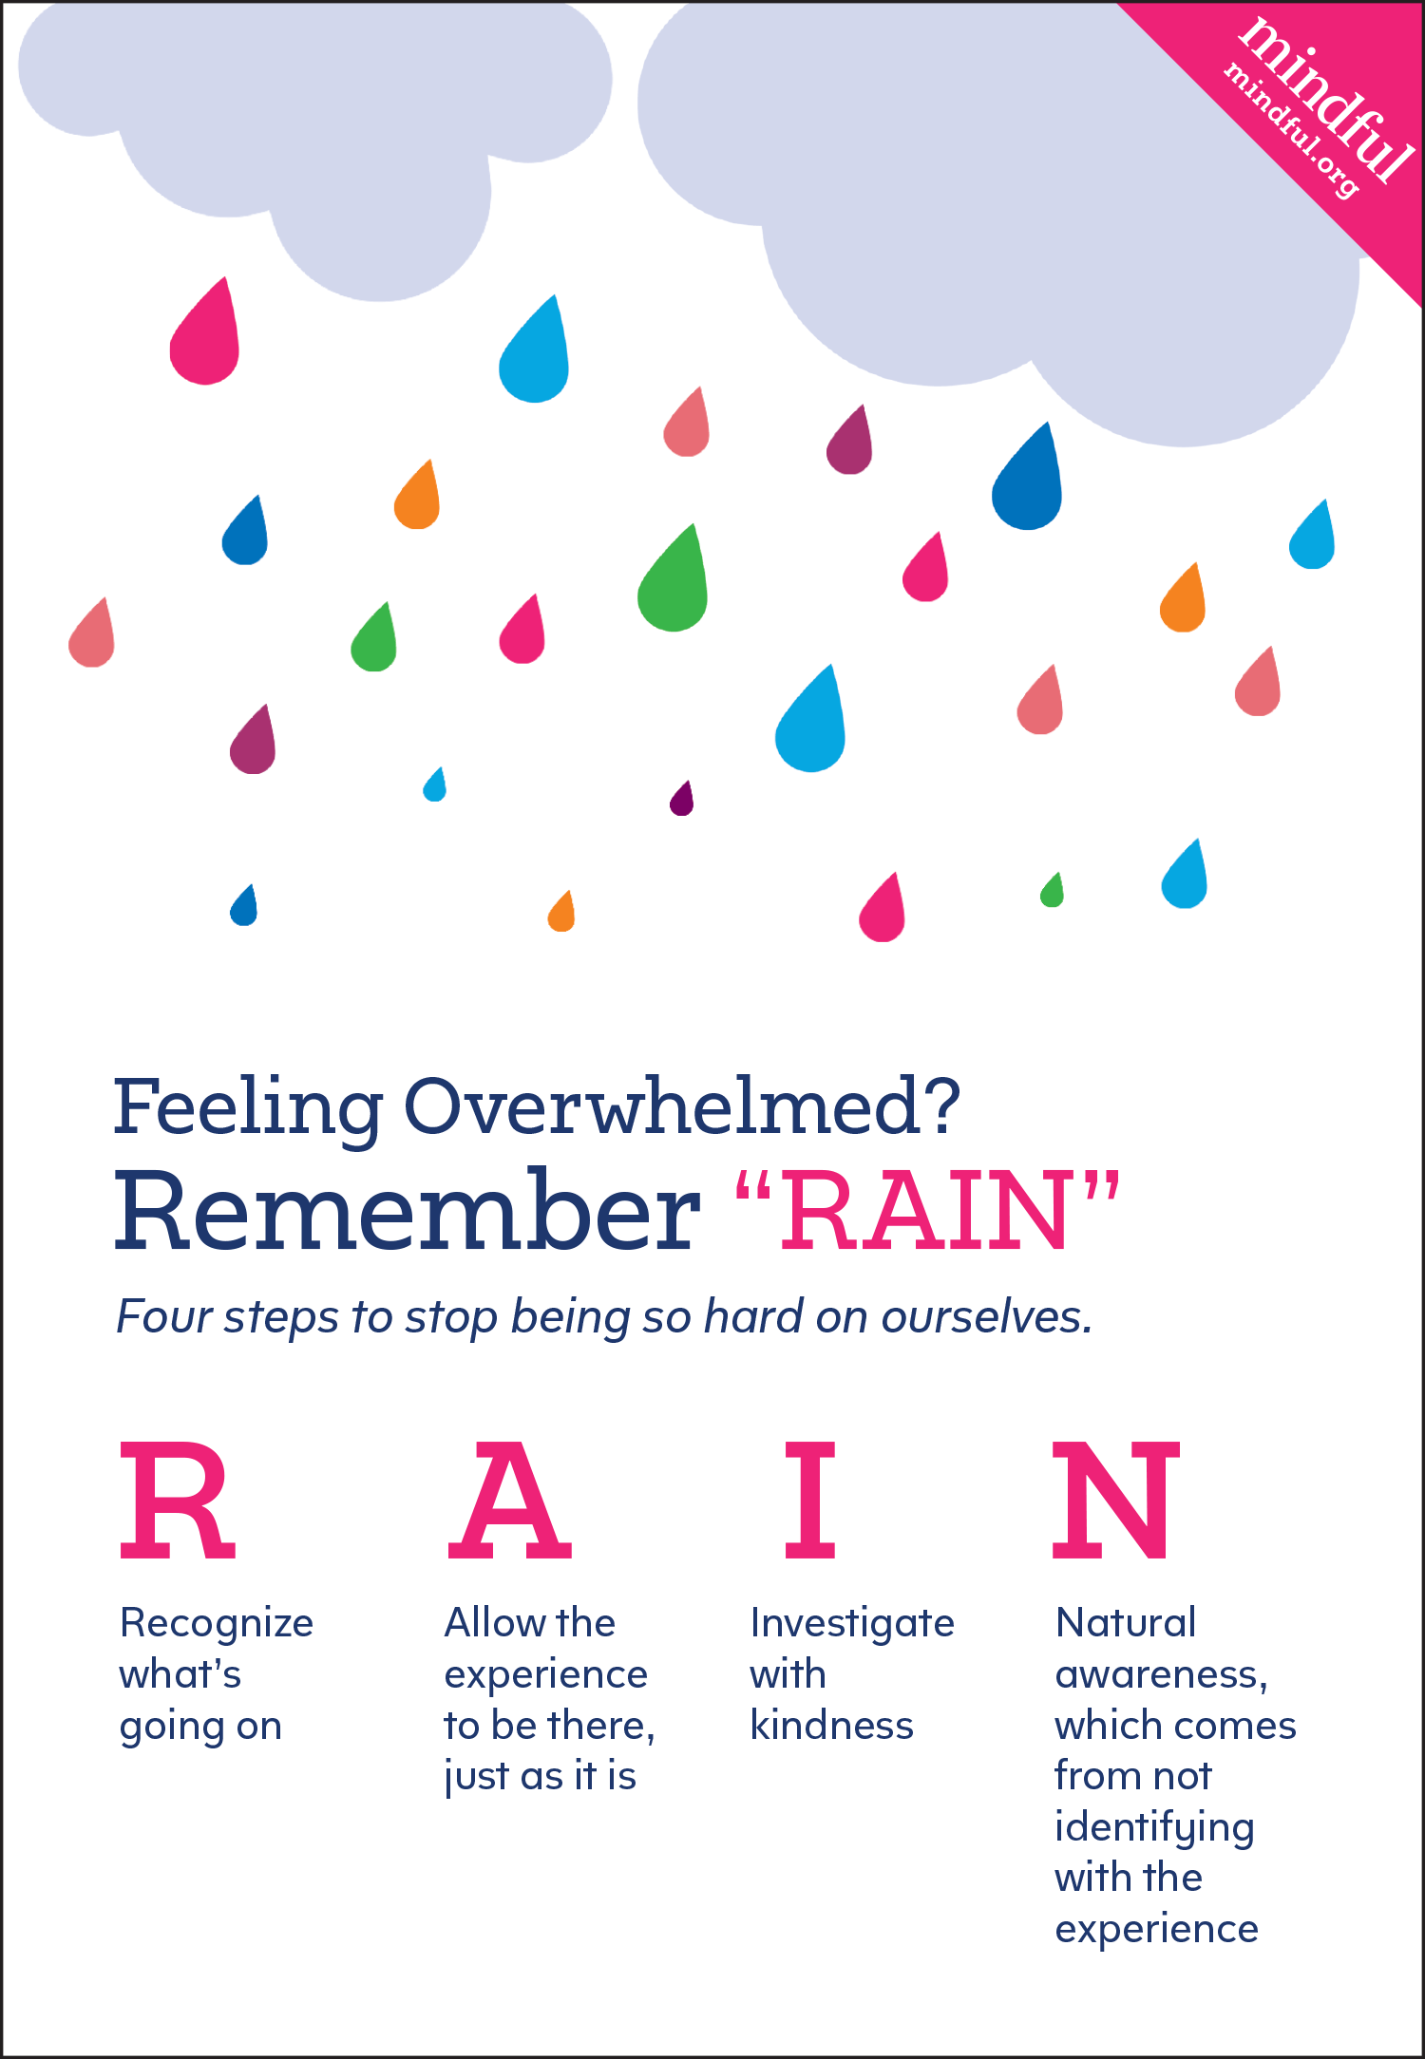
Mindfulness Practice

You can do any activity mindfully…

Exercise 1: Conscious Observation
Pick up an object that you have lying around. Any mundane everyday object will do...a coffee cup or a pen for example. Hold it in your hands and allow your attention to be fully absorbed by the object. Observe it. Don’t assess it or think about it, or study it intellectually. Just observe it for what it is.
Note: You can describe the objects by using only what you know and nothing more.
You’ll feel a sense of heightened "nowness" during this exercise. Conscious observation can really give you a feeling of "being awake". Notice how your mind quickly releases thoughts of past or future, and how different it feels to be in the moment. Conscious observation is a form of meditation. It’s subtle, but powerful. Try it...by practicing mindfulness in this way you’ll really start to sense what mindfulness is all about.

Exercise 2:
One person will say a 3 letter word. The person next to them will say a 3 letter word that starts with the middle letter of the previous person’s word. Group members continue doing this until everyone has participated several times.
Notice if your mind jumps into the future and comes up with a word, tries to guess what letter you might get, or worries about what others might think if you have difficulty coming up with a word. Each time one of those thoughts appears, gently and nonjudgmentally bring your mind back to the present.
You can do this activity by yourself. You can also choose longer words to do this activity with.

Exercise 3:
Choose one of your 5 senses: sight, sound, smell, taste, and touch. Now notice your experience of that sense in the present moment. For example, if you choose sound, notice the different noises you hear. Be aware of their changes in pitch, intensity, and volume. Notice which sounds start and which ones stop. Notice if there’s silence.
If you notice that your attention moves away from the sounds you notice, gently bring it back. If you notice judgments about the sound, gently acknowledge the judgment and bring your attention back to the present moment.
Exercise 4: The Ten Second Count
This is more of an exercise in practicing concentration than it is in mindfulness, and it is a simple variation on exercise 1. In this exercise, rather than focusing on your breath, you just close your eyes and focus your attention on slowly counting to ten. If your concentration wanders of, start back at number one! For most people, it goes something like this...
“One...two...three...do I have to buy milk today or did John say he’d do it? Oh, whoops, I’m thinking.”
“One...two...three...four...this isn’t so hard after all... Oh no....that’s a thought! Start again.”
“One...two...three... now I’ve got it. I’m really concentrating now...”

Exercise 5:
The group leader sets a timer for 3 minutes.
Everyone takes out a pen and a piece of paper, and writes the alphabet on the left hand side of the page. Take the next 3 minutes is to write animals that start with each letter of the alphabet.
Notice any judgments that come up about yourself or your list of words. Notice any comparisons you make between yourself and your peers, notice any tendencies to generalize from this exercise to your intelligence or your abilities. Gently move your attention from them and return to the task at hand.

Exercise 6:
Try to be mindful during an activity that you do every day. For example, brushing your teeth…
Notice which hand you pick up the toothbrush with and how it feels in your hand. What color is your toothbrush? Notice which hand you pick up your toothpaste with and how it feels to unscrew the cap and squeeze the toothpaste onto the toothbrush. What color is your toothpaste? Which teeth do you put the toothbrush against first? How do your teeth feel as you brush them? What does the toothpaste taste like?

Mindfulness Apps for iPhone and Android
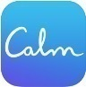
Calm
Runs on: iPhone and Android
Cost: Free (with in-app purchases)
This app offers both guided and unguided meditations with varying meditation lengths. The free ‘7 Days of Calm’ teaches the basics of mindfulness meditation by breaking down meditation techniques in easy to learn 10 minute sessions. (Recommendation: try the 7 days of Calm, then use the one month free membership to dive into the 21 days of Calm to deepen your mindfulness understanding and practice)
Headspace
Runs on: iPhone and Android
Cost: Free (with in-app purchases)
Headspace is meditation made simple by learning meditation and mindfulness in just 10 minutes a day. The app offers both guided and unguided lessons that range from 2 to 60 minutes long.
Smiling Mind
Runs on: iPhone and Android
Cost: Free
Described as modern meditation for young people, Smiling Mind is an Australian not-for-profit organization that offers a series of free mindfulness-based meditations through online and mobile apps. When you sign up, you can specify your age (7-11, 12-15, 16-22 or adult) to get tailored meditations.

Day | Pre-Stress Rating (0-10) | Skill Used | Post-Stress Rating (0-10) | How did it go?
HOMEWORK

We need to make small changes in our thinking and behavior EVERY DAY to more effectively manage stress.

