Week Three: Challenging Your Thinking

Today’s Agenda:
- Check-in
- Homework Review
- How Thinking Affects Us
- Cognitive Distortions
- How to Challenge Your Thoughts
- Practice Restructuring Thinking

Today’s Packet includes:
- Interpretations
- CBT Explanation
- Cognitive Distortions
- Challenging Negative Thinking
- Practice Restructuring Thinking
- Homework

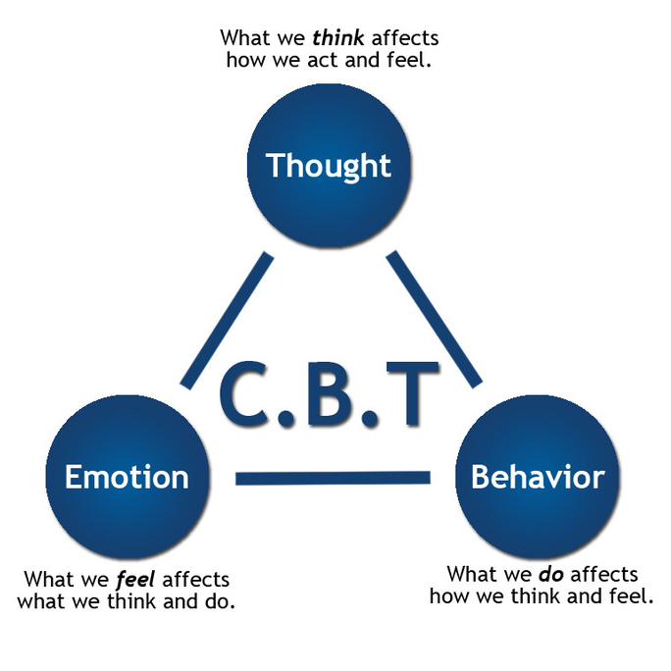

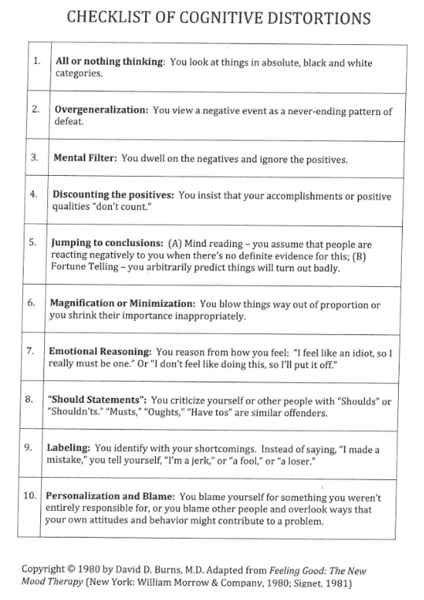
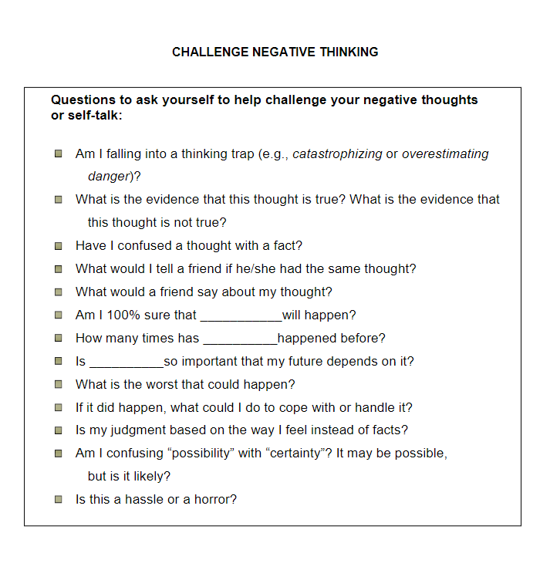
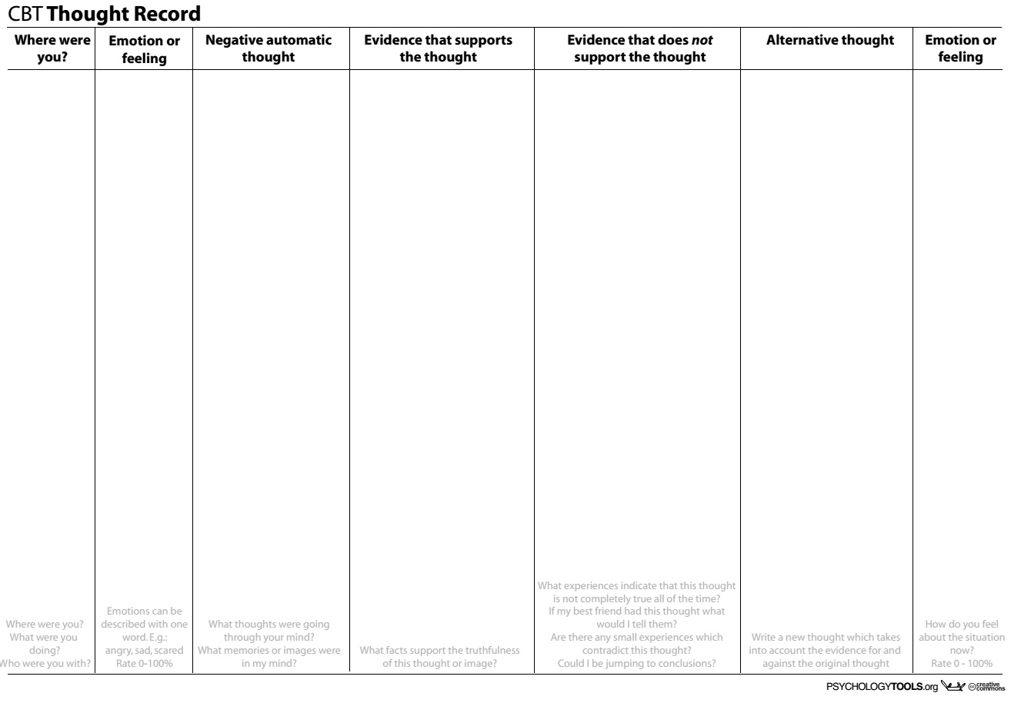
HOMEWORK
Day | Pre-Stress Rating (0-10) | Skill Used | Post-Stress Rating (0-10) | How did it go?

We need to make small changes in our thinking and behavior EVERY DAY to more effectively manage stress.

