Stretching and Warming Up – 8 Exercises
Holding these stretches for 15-20 seconds is the best way to end your workout. Do not bounce when performing these stretches and inhale deeply for three seconds, hold for three seconds and fully exhale. Do this twice per stretch. This will take you to the 15-20 second time minimum for holding these stretches for optimal results.
Shoulder Shrugs - Rotate your shoulders slowly up and down, keeping your arms relaxed by your side. Your shoulders should rotate in small circles and move up and down in slow distinct movements.

Chest Stretch - Grab a vertical and stationary object with your hand. Pull your body away from your arm in order to feel the stretch of your chest and shoulder connection. Also stretches your bicep.

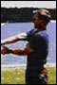
Forearm Stretch - With your opposite hand pull backwards on your hand while keeping your arm straight and palm pointing in an upward direction. You will feel this stretch in the forearm and bicep / elbow connection.

Arm / Shoulder Stretch - Drop your shoulder and pull your arm across your chest. With the opposite arm, gently pull your arm across your chest and hold for 15 seconds. Repeat with the other arm.

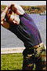
Triceps into Back Stretch - Place both arms over and behind your head. Grab your right elbow with your left hand and pull your elbow toward your opposite shoulder. Lean with the pull. Repeat with the other arm.

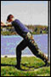
Calf Stretch into Achilles Tendon Stretch - Stand with one foot 2-3 feet in front of the other. With both feet pointing in the same direction as you are facing, put most of your body weight on your leg that is behind you - stretching the calf muscle. Now, bend the rear knee slightly. You should now feel the stretch in your heel. This stretch helps prevent Achilles tendonitis, a severe injury that will sideline most people for about 4-6 weeks.

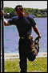
Thigh Stretch Standing - Standing, bend your knee and grab your foot at the ankle. Pull your heel to your butt and push your hips forward. Squeeze your butt cheeks together keep your knees close together. You can hold onto something for balance if you need to OR you can lie down on your hip and perform this stretch.
As you may know, the lower back is the most commonly injured area of the body. Many lower back problems stem from inactivity, lack of flexibility, and improper lifting of heavy objects. Stretching and exercising your lower back will help prevent some of those injuries. See lower back stretches and exercises in the "Workouts to Prevent Injury" article.
Hamstring Stretch #1 - From the standing or sitting position, bend forward at the waist and touch your toes. Keep your back straight and slightly bend your knees. You should feel this stretching the back of your thighs.

Bend knees slightly to stretch the top side of the hamstring as well as the lower back.

12 Exercises: 3 per page
Stretches for side of neck:  - Sit or stand with arms hanging loosely at sides  - Turn head to one side, then the other  - Hold for 5 seconds, each side  - Repeat 1 to 3 times | 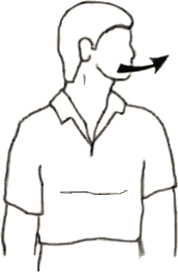
Stretches side of neck  - Sit or stand with arms hanging loosely at sides  - Tilt head sideways, first one side then the other  - Hold for 5 seconds  - Repeat 1-3 times | 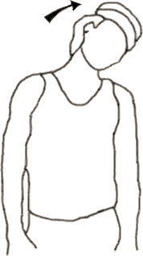
Stretches back of neck  - Sit or stand with arms hanging loosely at sides  - Gently tilt head forward to stretch back of neck  - Hold 5 seconds  - Repeat 1-3 times | 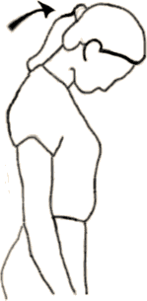
Stretches side of shoulder and back of upper arm  - Stand or sit and place right hand on left shoulder  - With left hand, pull right elbow across chest toward left shoulder and hold 10 to 15 seconds  - Repeat on other side | 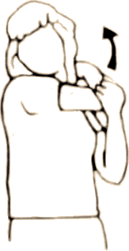
Stretches shoulder, middle back, arms, hands, fingers, wrist  - Interlace fingers and turn palms out  - Extend arms in front at shoulder height  - Hold 10 to 20 seconds, relax, and repeat | 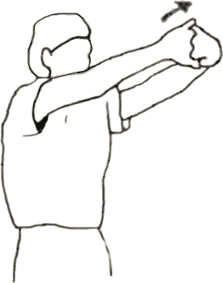
Stretches triceps, top of shoulders, waist  - Keep knees slightly flexed>  - Stand or sit with arms overhead  - Hold elbow with hand of opposite arm  - Pull elbow behind head gently as you slowly lean to side until mild stretch is felt  - Hold 10 to 15 sec  - Repeat on other side | 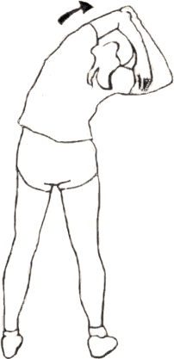
Stretches middle back  - Stand with hands on hips  - Gently twist torso at waist until stretch is felt  - Hold 10 to 15 sec  - Repeat on other side  - Keep knees slightly flexed | 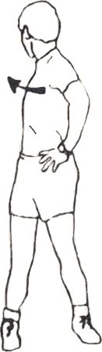
Stretches ankles  - Stand and hold onto something for balance  - Lift right foot and rotate foot and ankle 8 to 10 times clockwise, then 8 to 10 times counterclockwise.  - Repeat on other side  (Note: can also be done sitting) | 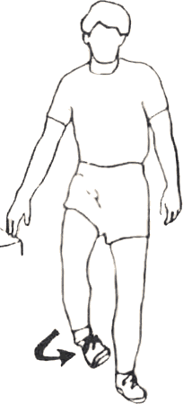
Stretches calf  - Stand a little way from wall and lean on it with forearms, head resting on hands  - Place right foot in front of you, leg bent, left leg straight behind you  - Slowly move hips forward until you feel stretch in calf of left leg  - Keep left heel flat and toes pointed straight ahead  - Hold easy stretch 10 to 20 seconds  - Do not bounce  - Repeat on other side  - Do not hold breath | 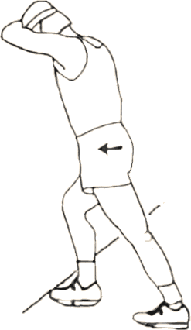
Stretches front on thigh (quadriceps)  - Stand a little a way from wall and place left hand on wall for support  - Standing straight, grasp top of left foot with right hand  - Pull heel toward buttock  - hold 10 to 20 sec  - Repeat on other side | 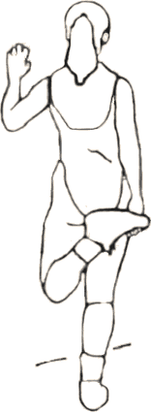
Relaxes hamstrings, stretches calves, achilles, and ankles  - Stand with feet shoulder-width apart  - Keep heels flat, toes pointed straight ahead  - Assume bent knee position (quarter squat)  - Hold 30 sec | 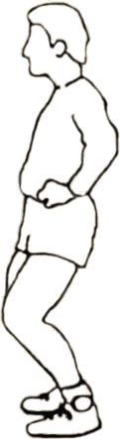
Stretches inner thigh, groin  - Stand with feet pointed straight ahead, a little more than shoulder-width apart  - Bend right knee slightly and move left hip downward toward right knee  - Hold 10 to 15 seconds  - Repeat on other side  - If necessary, hold on to something (chair, etc.) for balance | 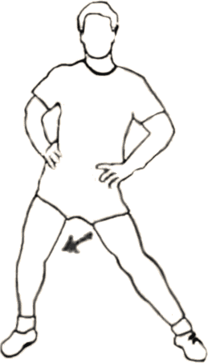

Stretching and Flexibility – 11 Exercises
After exercise and as a result of the aging process, there is a tendency for individual muscle fibers to get shorter. This muscle shortening puts increased stress on ligaments and joints, increasing the risk of arthritis. Stretching or performing flexibility training after each exercise session helps prevent this damage.
With age the muscles of the body have a natural tendency to shorten as well. Unless you stretch these muscles regularly, they will continue to shorten, which can lead to poor posture, decreased range of motion, muscle stiffness and other problems.
Many people find another profound benefit of stretching - a feeling of overall mental and physical relaxation as you breathe deeply and as the tension leaves the muscles during the stretch.
Flexibility Training Routines - Following aerobic exercise, perform lower body stretches and, if possible, a full series of stretches. When strength training, the full series of stretches should be done-- before beginning, stretch your neck, back and abdominals; after completing, stretch the muscles that were used in strength training.
- Stretching can be a little uncomfortable, but shouldn't hurt
- Stretch each muscle to the point of tension, but not to the point of pain
- Never try to stretch cold muscles
- Hold each stretch for up to 30 seconds, but don't bounce
- Perform neck, back, abdominal, upper body, and lower body stretches
- Breathe slowly, and inhale and exhale deeply
- If you only do flexibility training, do it at least three times a week

Neck Stretch (1)
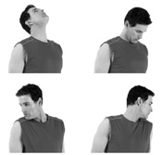
Neck Stretch
- Sit or stand and relax your shoulders.
- Let your head drop down slowly towards your chest until you feel a gentle pull in the muscles at the back of your neck. Hold for 8 to 10 seconds.
- Very gently push your head backwards until you feel a slight pull at the front of your neck.
- Don't go back as far as you can go. Hold for 8 to 10 seconds.
- Do the same exercise towards each side, letting your head gently drop towards your shoulders.
- Hold each side for 8 to 10 seconds.

Lower-Body Stretches (4)
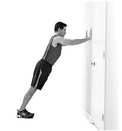
Calf Stretch
- Stand about 1 or 2 feet away from a wall with your toes pointing straight ahead.
- Hold your hands against the wall and lean your body toward the wall at a 45-degree angle as you press your heels down toward the floor as shown.
- You should feel the stretch in your calf muscles.
- Hold for 15 to 30 seconds.
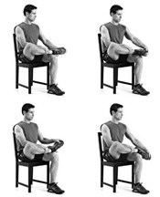
Ankle Stretch
- Sit on a sturdy chair and lift your right leg as shown.
- Use your right hand to hold your ankle and your left hand to hold your heel.
- Use your left hand to pull your foot towards you. Hold for 5 seconds.
- Then, push your foot away and hold for 5 seconds.
- Finally, rotate your foot first clockwise a few times, then counterclockwise a few times.
- Switch sides and repeat on your other ankle.
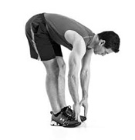
Hamstring Stretch
- Stand with your feet shoulder-width apart.
- Bend at the hips (not the waist), letting your upper body hang.
- Reach your hands towards the floor until you feel a slight stretch in your hamstrings.
- If needed, bend your knees slightly.
- If this stretch causes discomfort in your low back, keep your back straight and place your hands on your thighs.
- For a deeper stretch, place your palms flat on the ground.
- Hold for 15 to 30 seconds.
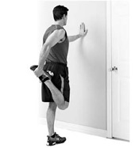
Anterior-Thigh (Quads) Stretch
- Balancing yourself with your left hand on the wall, take hold of your right foot or ankle and bring it behind you.
- Keep your left knee pointing down and your rear end tucked and not sticking out.
- Bring your heel as close to your buttock as possible without pain.
- Hold for 10 to 15 seconds, then repeat on the other side.

Upper-Body Stretches (6)
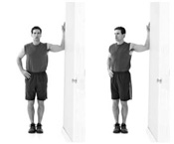
Chest Stretch
- Stand in a doorway facing perpendicular to the wall.
- Bend your arm to 90 degrees and place your forearm against the door jam.
- Rotate your body away from the door until you feel a stretch in your chest.
- Hold for 10 seconds, then repeat on the other side.
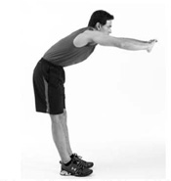
Upper-Back Stretch
- Extend your arms in front of you with your fingers interlaced and your palms facing forward.
- Push your hands forward while exhaling, allowing your back to arch slightly.
- Hold for 10 to 15 seconds.
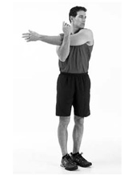
Shoulder Stretch
- Place your left arm across the front of your body.
- Hook your right elbow in front of your left elbow.
- Pull slightly to the right while turning your head slightly to the left.
- Hold for 15 to 30 seconds, then repeat on the other side.
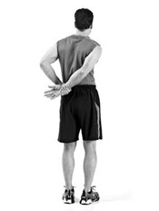
Deltoids Stretch
- With your hands behind your back, take hold of your right wrist with your left hand.
- Pull gently towards the left until you feel the stretch in the front of your shoulder.
- Hold for 10 to 15 seconds, then repeat on the other side.
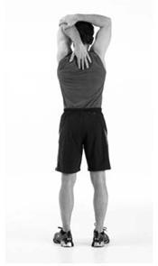
Triceps Stretch
- Lift your left arm straight overhead and then allow elbow to bend.
- Allow fingers to touch back between shoulder blades.
- Place your right hand across the top of your head and take hold of left elbow. Stand up straight and
- feel the stretch in left triceps.
- Hold for 10 to 15 seconds, then repeat on the other side.

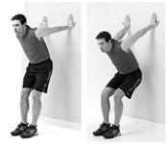
Biceps Stretch
- Face away from wall and bend over.
- Place hands close together, palms on wall as high on wall as possible. Point fingers towards ceiling.
- Squat down slowly.
- Hold for 15 to 30 seconds.

Tips and Resources
Yoga is a relaxing way to maintain flexibility and millions engage in this form of flexibility training.
If you sit at a desk all day, a lack of flexibility could lead to some serious back issues. There are plenty of simple stretches that you can do to increase your range of movement, including these at-your-desk stretches.
Golfers can benefit from these office exercises to improve their game.
Exercise like walking will strengthen your leg muscles, including the hamstrings and quadriceps. Keeping your hamstrings flexible is important to avoid straining your lower back. This stretch increases flexibility while protecting the spine.

1 Lower Back Exercise:

Lower Back Extension Exercise - backward bend
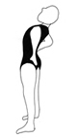 | You can't get much easier than this lower back exercise. This one can be practiced anywhere.
