Workday Adaptive Job Aid

Workday Adaptive Overview
Bentley completed the first phase of Workday Adaptive Planning, a replacement of the existing Workday Planning module which is a result of Workday’s acquisition of Adaptive Insights. As a Workday institution, Bentley was forced to migrate to this new technology platform this fiscal year as our legacy product was decommissioned. The Office of Financial Planning & Budgeting has implemented this new enterprise performance management (EPM) software.
Adaptive Planning provides:
  - Budgeting
  - Forecasting
  - Reporting
  - Analytics
  - Security
  - Integration with Workday

How to Access Adaptive Planning
- Click on the Adaptive Planning worklet on your home page
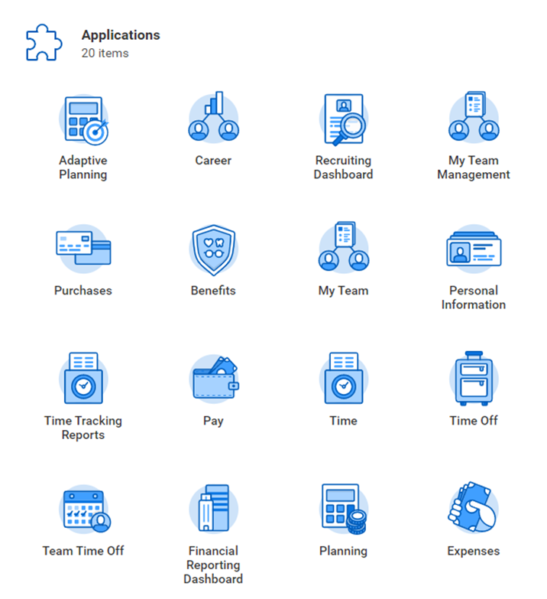

Next click on the grey Adaptive planning box
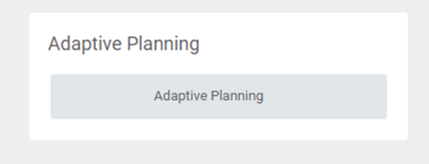
Sheet Navigation
Click on Workday Logo to access sheets available for entry.
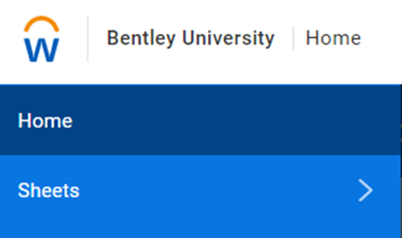
You should have access to Operating Distributed Model and Operating Distributed Model forecast. Click on each to ensure access to both sheets.
* There may be sheets that may show up with restricted access. Only sheets needed for Budget and Forecast will be available for cost center planners.
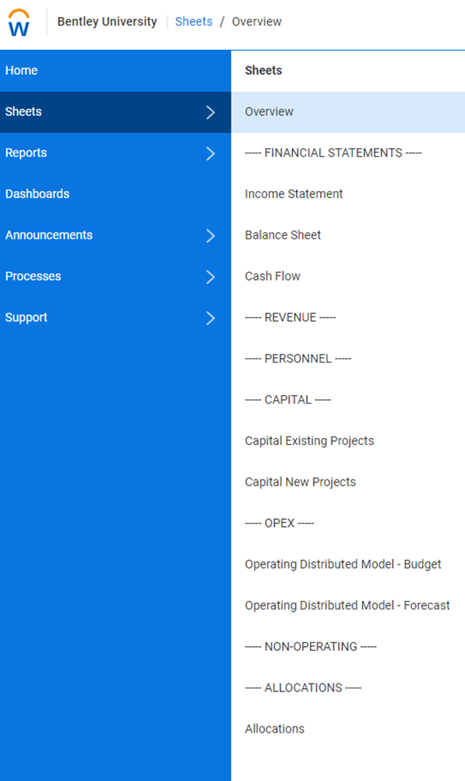

Operating Budget Adaptive Planning
- Access Adaptive Planning through your Workday Applications. Log into Workday, then select the Adaptive Planning worklet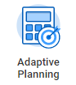
- Select Adaptive Planning button
- Navigate to the Workday logo on the top left of your screen
- Select Sheets then Operating Distributed Model - Budget under OPEX
- Before beginning, please ensure the parameters on the sheet are set as follows:
  - Version (in the top right of your screen): Next fiscal year (FY2023 Budget)
  - Time: Next fiscal year (FY2023)
  - Levels: Cost Centers on which you are assigned Cost Center Planner
  - Funds: 1100 Operating Fund – E&G
  - Operating_Account_Flag: Yes
  - Sheet_Accounts: Operating Model Accounts
- To only display rows which have a budget amount or actuals activity select Display Options and check the “Suppress rows if all zeros or blank” box.
- The Operating Distributed Model sheet allows for reallocation of budget amounts between ledger accounts as well as non-reallocation additions and reductions to the budget.
- To start, change the Levels parameter to a specific cost center. In the sheet, the “Base Budget” column displays the current budget for the next fiscal year. To enter any adjustments to your budget, enter values in the cells shaded in white in the “ADJ $” column. Attempting to enter data in other cells will cause the following error message “Locked: Linked account” which indicates that data cannot be accessed or changed.
- Once you’ve entered your adjustments, the value in the “ADJ $” column will appear in blue font. To save your changes, select the Save button . Once saved, your adjustments will appear in black font and the “Total Budget Request” column will be updated to include Base Budget + ADJ $.
- For each addition/reduction entered, please add an explanation. Do this by right clicking on the cell and selecting “Add Note”. Once you’ve entered your note, click OK. You can also add a note to the entire sheet by selecting the “Add Sheet Notes” button on the top right of your screen

Operating Forecast Adaptive Planning
- Access Adaptive Planning through your Workday Applications. Log into Workday, then select the Adaptive Planning worklet
- Select Adaptive Planning button
- Navigate to the Workday logo on the top left of your screen
- Select Sheets then Operating Distributed Model - Forecast under OPEX
- Before beginning, please ensure the parameters on the sheet are set as follows:
  - Version (in the top right of your screen): Current fiscal year forecast (FY2022 Jan Forecast)
  - Time: Current fiscal year (FY2022)
  - Levels: Cost Centers on which you are assigned Cost Center Planner
  - Funds: 1100 Operating Fund – E&G
  - Operating_Account_Flag: Yes
  - Sheet_Accounts: Operating Model Accounts
- To only display rows which have a budget amount or actuals activity select Display Options and check the “Suppress rows if all zeros or blank” box.
- The Operating Distributed Model - Forecast sheet allows for reallocation of budget amounts between ledger accounts as well as non-reallocation additions and reductions to the budget.
- To start, change the Levels parameter to a specific cost center. In the sheet, the “CY Budget” column displays the budget for the current fiscal year. To enter any adjustments to your budget, enter values in the cells shaded in white in the “ADJ $” column. Attempting to enter data in other cells will cause the following error message “Locked: Linked account” which indicates that data cannot be accessed or changed.
- Once you’ve entered your adjustments, the value in the “ADJ $” column will appear in blue font. To save your changes, select the Save button . Once saved, your adjustments will appear in black font and the “Total Forecast Request” column will be updated to include CY Budget + ADJ $.
- For each addition/reduction entered, please add an explanation. Do this by right clicking on the cell and selecting “Add Note”. Once you’ve entered your note, click OK. You can also add a note to the entire sheet by selecting the “Add Sheet Notes” button on the top right of your screen .

Adaptive Reporting and Dashboard

Operating Budget & Forecast Adaptive Planning Reports:
- Access Adaptive Planning through your Workday Applications. Log into Workday, then select the Adaptive Planning worklet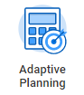
- Select Adaptive Planning button
- Navigate to the Workday logo on the top left of your screen
- Select Reports
- Select Shared and click on the Bentley Adaptive Planning Reports folder
- To view your requested budget by ledger account, select the Budget Summary by Ledger Account report
- In the Time dropdown, select the next fiscal year (FY2023)
- In the Version dropdown, select the next fiscal year budget (FY2023 Budget)
- In the Level dropdown, select the cost center or cost center hierarchy you would like to view and then click Run Report
- To view this report for another cost center, select the cost center in the Level dropdown in the top left of your screen, and then click on the Run Report button
- To view your requested budget by cost center, select the Budget Summary by Cost Center report in the Bentley Adaptive Planning Reports folder
- In the Time dropdown, select the next fiscal year (FY2023)
- In the Version dropdown, select the next fiscal year budget (FY2023 Budget)
- In the Level dropdown, select the cost center or cost center hierarchy you would like to view and then click Run Report
- In the Account Type dropdown, select the account type (Income, Expense, or Net Total) you would like to view
- In the Ledger Account dropdown, select “Ledger_Account” to view all ledgers or select the ledger account you would like to view
- To view this report for another ledger account and/or cost center, select the ledger in the Ledger Account dropdown and/or cost center in the Level dropdown in the top left of your screen, and then click on the Run Report button
- To view your requested forecast by ledger account, select the Forecast Summary by Ledger Account report
- In the Time dropdown, select the current fiscal year (FY2022)
- In the Version dropdown, select the current forecast (FY2022 Jan Forecast)
- In the Level dropdown, select the cost center or cost center hierarchy you would like to view and then click Run Report
- To view this report for another version and/or cost center, select the Change Parameters button and select the version and/or cost center in the Version and Level dropdowns and then click Run Report
- To view your requested forecast by cost center, select the Forecast Summary by Cost Center report
- In the Time dropdown, select the current fiscal year (FY2022)
- In the Version dropdown, select the current forecast (FY2022 Jan Forecast)
- In the Level dropdown, select the cost center or cost center hierarchy you would like to view
- In the Account Type dropdown, select the account type (Income, Expense, or Net Total) you would like to view
- In the Ledger Account dropdown, select “Ledger_Account” to view all ledgers or select the ledger account you would like to view
- To view this report for another version, ledger and/or cost center, select the Change Parameters button and select the version, ledger and/or cost center in the Version, Ledger Account and/or Level dropdowns and then click Run Report

Operating Budget & Forecast Adaptive Planning Dashboard:
- Access Adaptive Planning through your Workday Applications. Log into Workday, then select the Adaptive Planning worklet
- Select Adaptive Planning button
- Navigate to the Workday logo on the top left of your screen
- Select Dashboards
- Select Adaptive Planning Dashboard
- In the blue ribbon, select the time and level/cost center you would like to view
- In the top right of your screen, select the version you would like to view
- To view budget amounts by cost center or by ledger account select the budget version (FY2023 Budget)
- To view forecast amounts by cost center or by ledger account select the forecast version (FY2022 Jan Forecast)
- The following additional reports are available in the Shared Reports folder:
- Budget Summary by Ledger Account
- Budget Summary by Cost Center
- Forecast Summary by Ledger Account
- Forecast Summary by Cost Center

Adaptive Support
If you have any questions or issues, please contact the Budget Office at GA_BudgetOffice@Bentley.edu

